Summary

The RBSP EFW FM1 and FM2 Full-Up Science tests were carried out in Nov and Dec 2010 using RBSP_EFW_INT_011 ([1], Instrument Full-Up Science Test procedure). Detailed dates are included in the test description and results section below.

The Full-Up Science Test exercises the full AC dynamic range of the entire EFW instrument under realistic DC biasing and offset conditions, and serves to directly verify the large-amplitude E-field measurement requiurements detailed in the RBSP STARD [2].

The Full-Up Science Test for both FM1 and FM2 was successful. Both FM1 and FM2 performed nominally in the test, and the requisite dynamic ranges and levels of crosstalk were verified on both units.

Report prepared by:

John Bonnell (UCB Institutional PI/PM, EFW Science Team Member)

______________________________

Data Review

Michel Ludlam (EFW SysEng)

______________________________

Jorg Fischer ( EFW MAM)

________________________________

Revision History

Revision | Author | Notes
A | Bonnell (UCB) | Initial version.

References

Reference Number | Document | Notes
1 | RBSP_EFW_INT_011  https://efw.ssl.berkeley.edu/svn/GSE/003_docs-new/RBSP_EFW_INT_011_Full-up_Science_Test_Procedure.pdf
2 |  | RBSP STARD

Test Description and Results

General Summary
Refer to [1], as well as the relevant portions of the FM1 and FM2 instrument travelers for detailed information on the AS-RUN set up and measurements.

RBSP-EFW-FM1
Dates: 16 Dec 2011

Run details:

See FM1 instrument traveler for Full-Up test procedure and supporting notes.

Originally, this test was designed as an exhaustive slog through measurement parameter space (DC offset, AC amplitude and frequency, bias state), measuring both the analog inputs to and digital measurements by the EFW instrument. It was soon discovered that this was extremely time consuming (>2 days/run due to limited bitrate out of the instrument for burst data) and not very illuminating.

A limited set of test cases was then determined and run as part of the check out of the script that implemented the full automated test, and the results of those tests were taken as the primary data set.

Results:

Raw TM from the various manual and automated test runs can be found in the following locations:

https://efw.ssl.berkeley.edu/data/gse/20101209_113136_UUT4_/
https://efw.ssl.berkeley.edu/data/gse/20101216_141950_UUT4_FM1_FullUpTest/
https://efw.ssl.berkeley.edu/data/gse/20101216_144430_UUT4_FM1_fullup_test/

Based on inspection of the data during the manual runs, the quality of the data from FM1 was the same as that from FM2.

RBSP-EFW-FM2
Dates: 27 Dec 2010.

Run Details:

See FM2 instrument traveler for Full-Up test procedure and supporting notes.

Unlike the FM1 runs, which started out as an attempt at an exhaustive, automated walk-through measurement parameters (amplitude, frequency, biasing), the FM2 Full-Up test targeted a particular set of parameters most relevant for verifying the EFW instrument performance requirements. These parameters are tabulated below:

Case Number | UTC of Burst Collection | DC Offset [V] | AC Amplitude [Vpp] | AC Frequency [Hz] | Bias Table | Comments
1 | 2010-12-28 02:59:10 | 0 | 100 | 100 | 1 | LHyb wave.
2 | 2010-12-28 03:28:58 | -40 | 100 | 100 | 1 | LHyb wave.
3 | 2010-12-28 03:49:46 | 0 | 40 | 1000 | 1 | Whistler wave.
4 | 2010-12-28 04:09:46 | -40 | 40 | 1000 | 1 | Whistler wave.
5 | 2010-12-28 04:50:24 | -40 | 100 | 1 | 3 | Perigee pass.
6 | 2010-12-28 05:33:10 | 0 | 100 | 1 | 1 | Perigee pass.
7 | 2010-12-28 06:10:48 | -40 | 100 | 1 | 1 | Perigee pass.

Results:

Raw TM data from the run can be found in the following location:
https://efw.ssl.berkeley.edu/data/gse/20101227_152939_UUT5_FM2_FullUp_Test/

The two plots below show the results of the 4th run in the table above, which simulates a large-amplitude (400 mV/m) whistler wave in a sunlit, low-density plasma environment (large DC offset). The E12 and V1 signals have the realistic amplitude and clean response that will be seen on orbit due to the AC attenuation factor of the sheath-preamp interaction. The other channels show the expected slew-rate limited behavior due to finite floating ground drive bandwidth (500 Hz), and finite preamp power supply rails (+/- 15 V). The cross talk is on the order of 0.1%, well within EFW measurement goals of less than 1% AC crosstalk (40 dB).
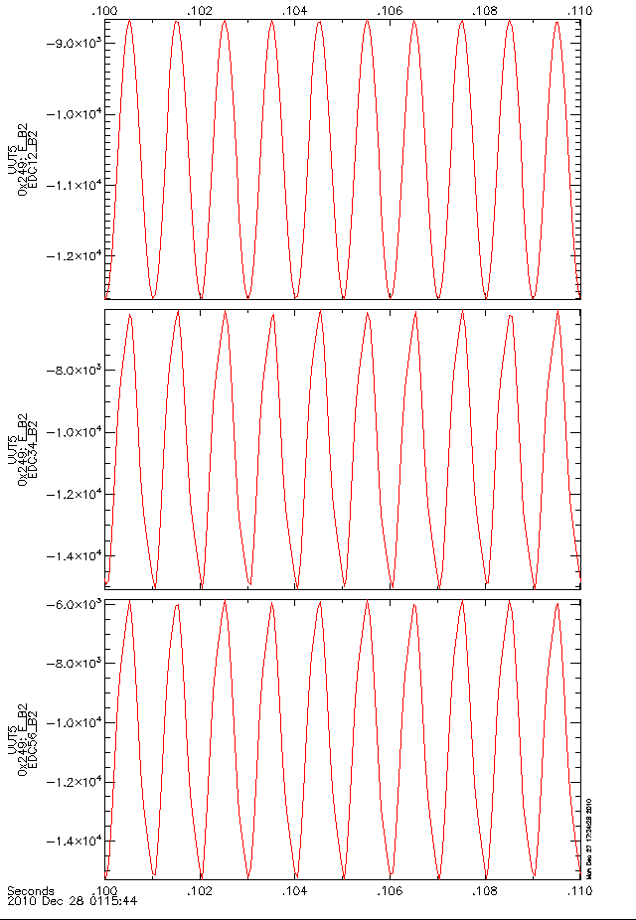
Figure 1: E_B2 16-ksamp/s E-field estimates.

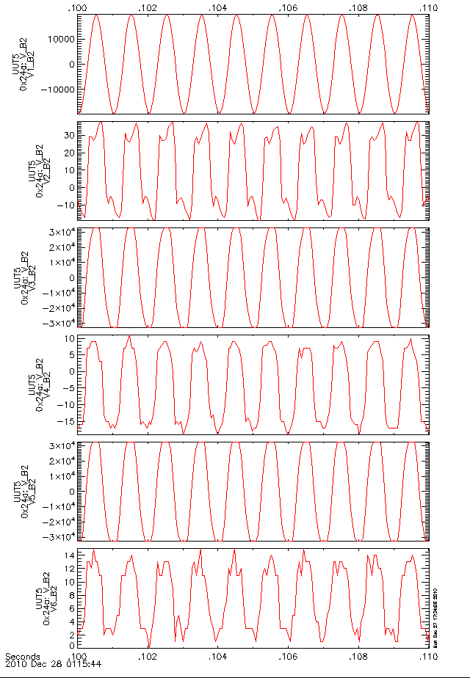
Figure 2: V_B2 16-ksamp/s Ac-coupled V (sensor potential) estimates.

The next two plots show the results from case 0 above, which corresponds to a large-amplitude, very low-frequency signal akin to that that would be observed during a perigee pass. Note that this was a special configuration where only a single sensor was excited in order to stringently test the cross talk between the various channels. The amplitudes were as expected, and the crosstalk was again on the order of 0.1%, well within the EFW measurement goals and requirements.

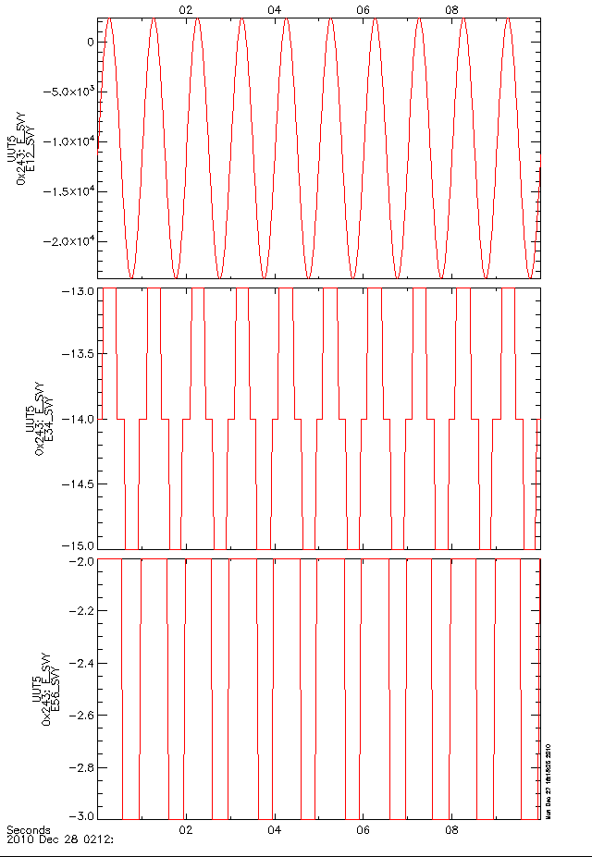
Figure 3: E-SVY, 32 samp/s.

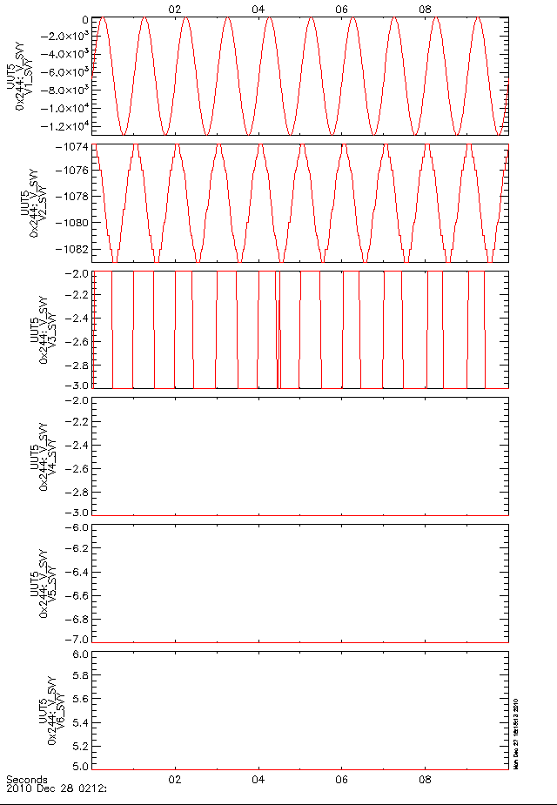
Figure 4: V-SVY, 32 samp/s.

The other runs produced similar results.

OTHER SECTIONS
none.

