Summary

The RBSP EFW FM1 and FM2 Noise, Phasing and Timing (NPT) tests were carried out in Nov and Dec 2010 using RBSP_EFW_INT_009 ([1], Instrument Noise, Phasing and Timing Test procedure). Detailed dates are included in the test description and results section below.

The NPT characterizes the noise floor of the EFW-EMFISIS analog E-field interface in both the low- (up to 10 kHz) and high-(up to 400 kHz) frequency regimes, as well as verifying the accuracy of waveform time tagging to the levels required by the RBSP STARD [2].

The NPT test for both FM1 and FM2 was successful. Both FM1 and FM2 performed nominally in the Timing test, with waveform data consistent with the expected analog and digital time delays through the EFW instrument. For FM2, the noise floor and line emissions present on the EFW/EMFISIS E-field interface were successfully measured and were found to be well below the required levels implied by the sensitivity requirements on that interface with noise floors well below the required levels for the E-field interface. For FM1, some setup and hardware issues interfered with the accurate estimation of the noise floor and line emissions present on the E-field interface, but the two units are identical in design and nearly identical in construction, and so the results from FM2 can stand for those of FM1 at this point in the integration and test flow.

Report prepared by:

John Bonnell (UCB Institutional PI/PM, EFW Science Team Member)

______________________________

Data Review

Michel Ludlam (EFW SysEng)

______________________________

Jorg Fischer ( EFW MAM)

________________________________

Revision History

Revision | Author | Notes
A | Bonnell (UCB) | Initial version.

References

Reference Number | Document | Notes
1 | RBSP_EFW_INT_009
2 |  | RBSP STARD
3 | https://efw.ssl.berkeley.edu/svn/DFB/EIDP and Test Reports
4 | RBSP_EFW_DFB_DSP_Algorithm_Overview_04.pdf
5 | 2010_09_02 WAVE_Digital_Filter_Delays Results.jpg
6 | RBSP_EFW_TR_026A_FM1_FM2_SciCal
Test Description and Results

General Summary

Refer to [1], as well as the relevant portions of the FM1 and FM2 instrument travelers for detailed information on the AS-RUN set up and measurements.

Note that originally there was to have been a separate phasing test, where the end-to-end phase shift of the entire analog and digital signal chain were to have been measured. Given the good knowledge of the analog phase shifts provided by the board-level testing of the EFW-DFB PWAs prior to delivery [3], as well as for the rest of the analog signal chain as part of the System-level SciCal testing [6], such a test was deemed unnecessary. Only the digital time delay was measured and compared against that predicted from the DFB design, and measured in the DFB board-level testing [4,5], given that an end-to-end verification of the digital (DFB and FSW) time delays is required to verify the system time tagging accuracy requirements [2].

RBSP-EFW-FM1

Noise Test --
Date: 3 Dec 2010.

Run details:
- Sensors terminated to ground either via P-SIM (79 Mohm || 9.8 pF; EFW X-axis, Science U-axis) or low-impedance (few ohm; EFW Y- and Z-axes, Science V- and W-axes).
- Both pairs of SPBs in FBOXes (EFW X- and Y-axes); AXBs (EFW Z-axis) in cradles on lab bench – allows effect of termination impedance and ambient noise to be observed (no significant effect of termination observed).
- All chassis connections for EFW (AXBs, SPBs, IDPU) star-grounded to IDPU chassis.
- Output of EMFISIS buffers through EMFISIS E-field I/F simulator measured using FFT capability of TEK scope.

Difficulties with setup (grounding, harness shielding, spectrum analyser setup) led to significant, and probably non-characteristic, line emissions being present in both the 0 to 12 kHz and 0 to 500 kHz noise floor measurements, as well as an estimate of the noise floor that was significantly higher than that measured on the EFW ETU, as well as subsequently on the EFW FM2, and was not consistent with the available analog and digital waveform data.

This noise floor estimation is useful for buying down the risk that the EMFISIS E-field interface will be too noisy to meet measurement requirements once EFW and EMFISIS are integrated to the spacecraft. The setup with just a single one of the two instruments is not ideal, but is the best that can be achieved at this point in the integration flow.

Given the detailed similarity between the FM1 and FM2 EFW instruments, it is felt that the more detailed and accurate results available for the FM2 unit serve to characterize the design and both units at this time.

Phasing/Timing Test --

Date: 6 Dec 2010

Run Details:
- EFW Sensors driven via low-impedance voltage source or hard-grounded to signal ground.
- EFW MAG and MSC interfaces driven through MAG and MSC I/F simulators.
- IDENTICAL triggered tone burst signal applied to selected inputs (typ. V1, V3, V5; MAG_U, MAG_W; MSC_U, MSC_W) at known MET.
- EFW Waveform (Survey, Burst1 and Burst2) TM collected.
- Data time-tagged and plotted using EFW near-real time analysis tool (IDL/EFWPLOT).
- Relative and absolute time delays of each channel and APID computed and compared to model based on FSW and DFB design and testing.

Results:

Raw TM data taken during the FM1 timing test can be found in the following location:
https://efw.ssl.berkeley.edu/data/gse/20101206_115208_UUT4_/

- Tone burst of 4 cycles of 10-Hz sine wave applied at 2010-12-06/21:23:05.
- Sampled at 32 samp/s (SVY), 512 samp/s (B1), and 16384 samp/s (B2).
- Absolute time delays as expected from DFB and FSW time tagging delays:

C:\Documents and Settings\jbonnell\My Documents\LWS\RBSP\RBSP-EFW-INT\RBSP-EFW-Time Tagging-revA.xlsx
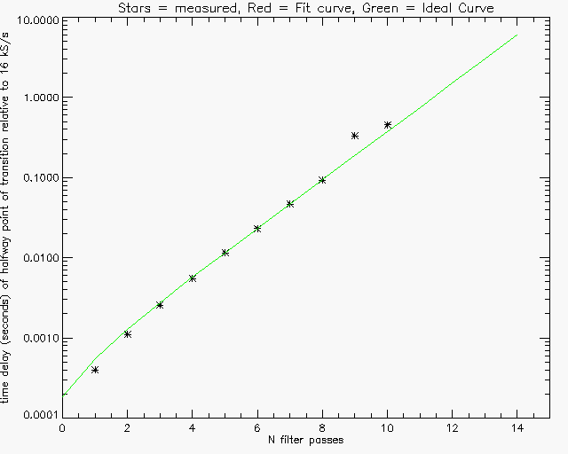

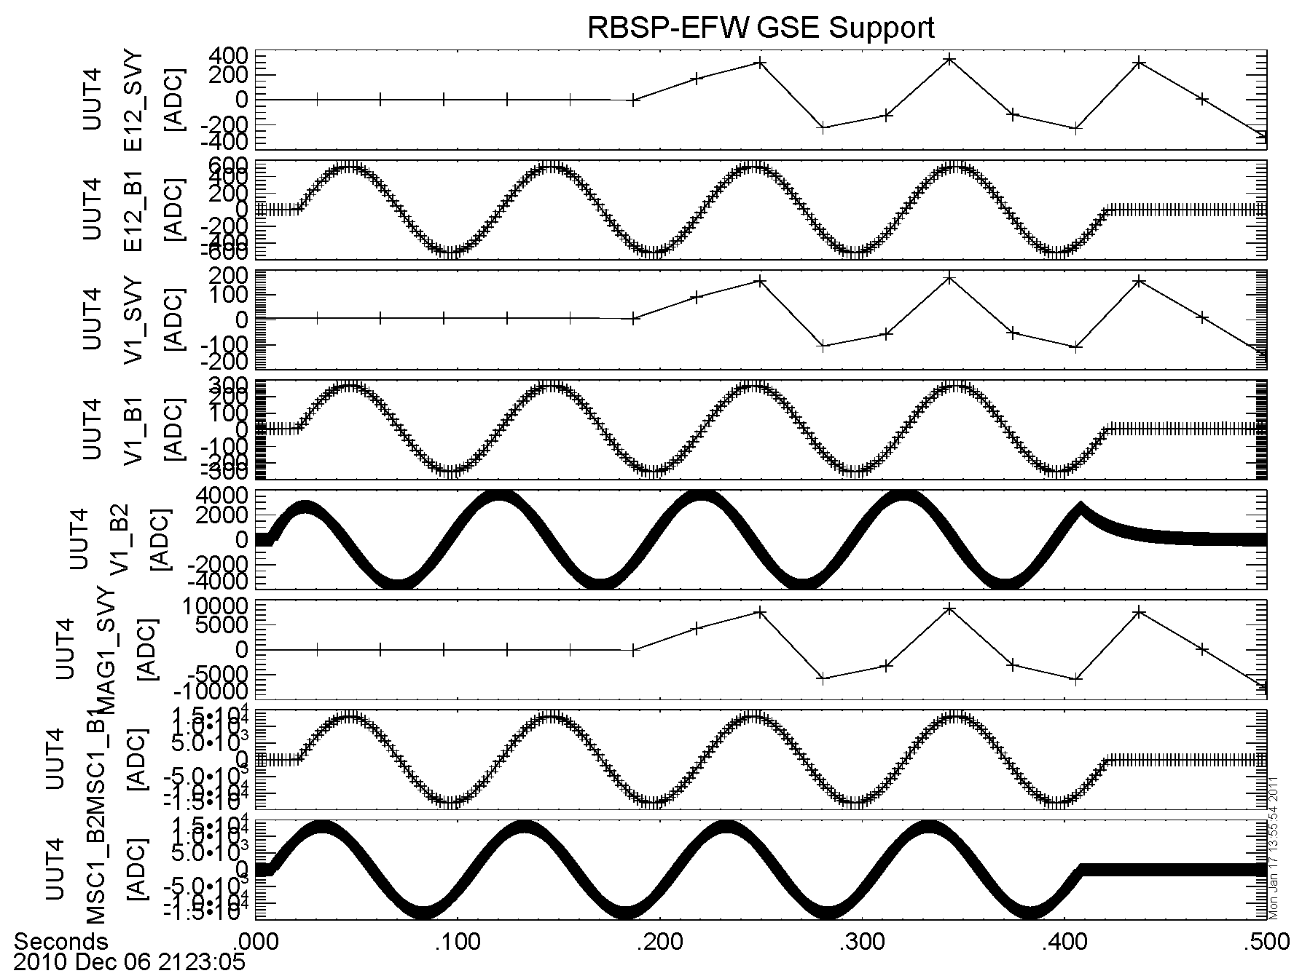
Figure 1: Same as preceeding figure, but shorter time scale (0.1-s, rather than 0.5-s), zooming in on relative delay between higher-rate channels (B1 and B2).

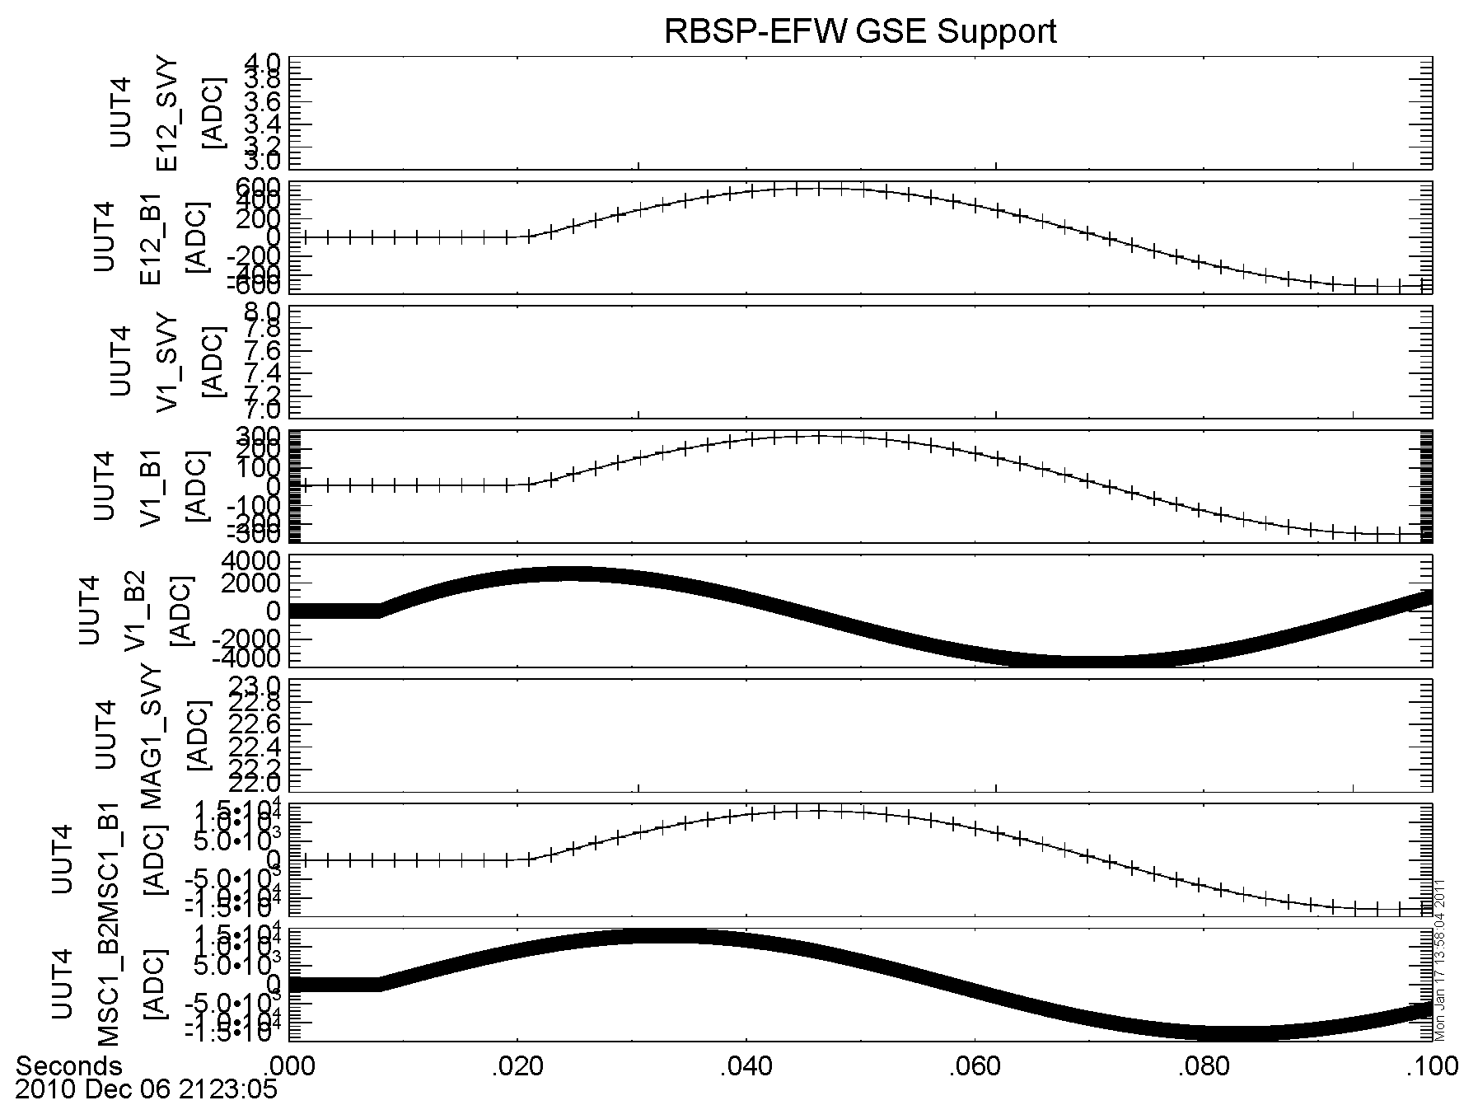

RBSP-EFW-FM2

Noise Test --
Date: 29 Dec 2010.

Run details:
- Sensors terminated to ground either via P-SIM (79 Mohm || 9.8 pF; EFW X-axis, Science U-axis) or low-impedance (few ohm; EFW Y- and Z-axes, Science V- and W-axes).
- Both pairs of SPBs in FBOXes (EFW X- and Y-axes); AXBs (EFW Z-axis) in cradles on lab bench – allows effect of termination impedance and ambient noise to be observed (no significant effect of termination observed).
- All chassis connections for EFW (AXBs, SPBs, IDPU) star-grounded to IDPU chassis.
- Output of EMFISIS buffers through EMFISIS E-field I/F simulator measured using spectrum analyser.
- Tabular and numerical data recorded using SOFTPlot utility.
- Data recorded and shown on following plots in dBm (dB mW into 50-ohm load) – conversions to (V/m)²/Hz are as follows:
  - 0-12 kHz, 150-Hz BW, 100-m antenna: -100 dB mW is equivalent to 3.3*10⁻¹⁸ (V/m)²/Hz.
  - 0-500 kHz, 73-Hz BW, 100-m antenna: -100 dB mW is equivalent to 6.8*10⁻¹⁸ (V/m)²/Hz.
- Noise characterization shows significant margins (10 to 40 dB) between continuum noise floor and sensitivity specification (noise floor at S/N=1), similar to those measured on the EFW ETU.

Results:

Plots, screenshots and tabular data taken during the Noise test can be found in the following location: https://efw.ssl.berkeley.edu/svn/I&T/Instrument/FM/Noise_Phasing_Timing/

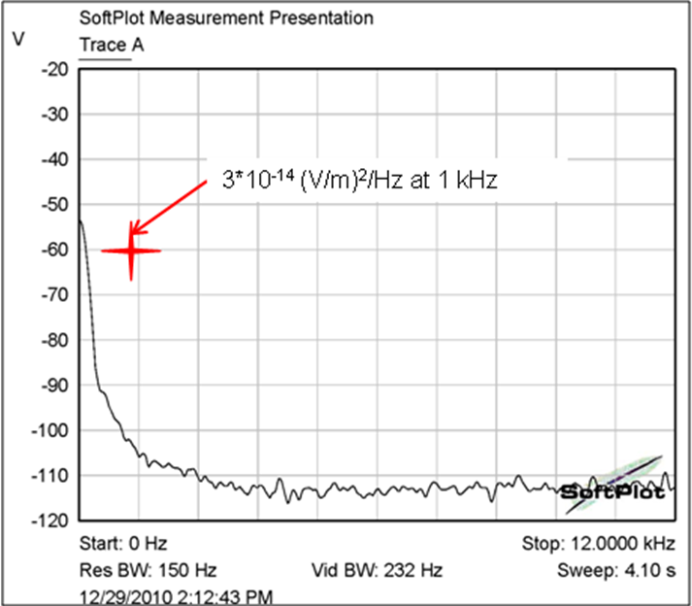
Figure 2: EFW EMFISIS E-field buffer output, U-axis, 0-12 kHz, showing >40 dB margin on noise floor requirement for S/N=1 sensitivity.

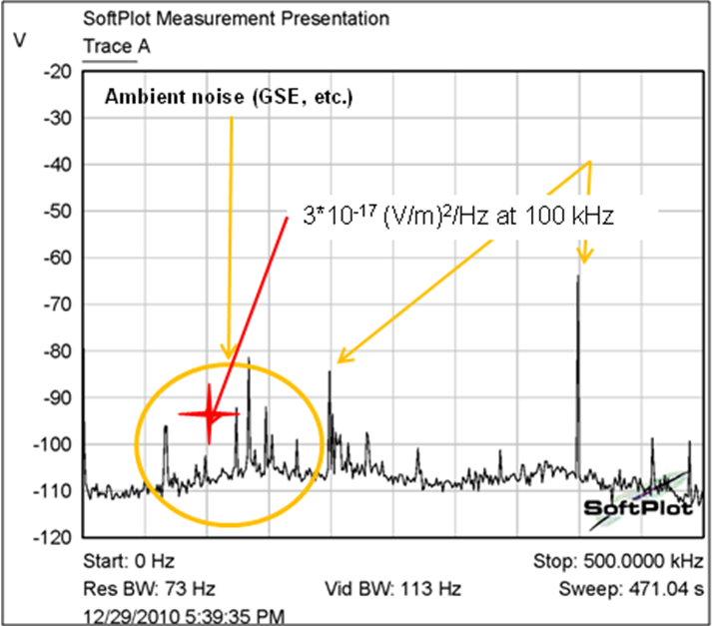
Figure 3: EFW/EMFISIS E-field interface, U-axis, 0-500 kHz, showing ~10 dB margin over noise floor requirement for S/N=1 sensitivity.

Results in the 0-12 kHz band for the Y- and Z-axes are essentially identical to those observed for the X-axis; the noise floor sits at or below -115 dBm over most of the frequency band, and there is at least 40 dB of margin present between the required noise floor for S/N=1 and the observed noise floor at 1 kHz.

Results in the 0-500 kHz band for the Y- and Z-axes are essentially identical to those observed for the X-axis; in each case there is at least 10 dB of margin between the required noise floor for S/N=1 and the observed noise floor at the fiducial frequencies. Excursions above the noise floor at fundamentals and harmonics of the switching power supply frequencies were observed, but we within the N*(50 kHz) “free fire zones”, and were of a low enough amplitude (few tens of mVpp) not to be at risk of saturating the E-field interface channels.

Phasing/Timing Test --
Date: 27 Dec 2010

Run details:

As noted in FM1 Timing test.

Raw TM data from the test can be found in the following location:
https://efw.ssl.berkeley.edu/data/gse/20101227_144238_UUT5_FM2_Timing_Test/

Results are the same as with the FM1 timing test; the observed waveform data demonstrated the expected digital time delays predicted from the DFB waveform data processing algorithm.

OTHER SECTIONS
none.

