RBSP
LVPS STABILITY Test
Test Report

RBSP_EFW TR_022

Peter Berg, U.C. Berkeley

Document Revision Record
Rev. | Date | Description of Change

Distribution List
Name | Email
Michael Ludlam, Systems  Keith Goetz, PM  John Bonnell, Inst CoI  Jorg Fischer, QA | mludlam@ssl.berkeley.edu  goetz@umn.edu  jbonnell@ssl.berkeley.edu  jorg@ssl.berkeley.edu

TBDs
Identifier | Description

Reference Documents
Ref | Doc Number | Title

Overview
The RBSP LVPS board contains four pulse width modulated voltage regulators. In previous missions, time domain testing was used to demonstrate stabily. While viewing the output of the control amplifier, the regulated output would be pulse loaded at a rate slow enough to view instabilities throughout the input voltage range.

At the RBSP CDR action item 003 required time domain testing of the regulators to show adequate phase margin of the control loops.

Test Procedure
The plan is to apply various input voltages and loads to each of the pulse width modulated regulators and, using specialized test instrumentation, plot and save the BODE plots of phase and gain versus frequency.

BODE Tester
A custom BODE plotter and software was purchased from Newtons 4th. It is designed especially to insert swept tones into operating power supplies, plot the phase and gain and display the results on screen

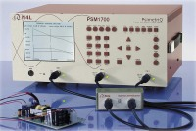
Figure 1. BODE PLOTTER WITH TRANSFORMER AND SAMPLE POWER SUPPLY

Signal Insertion Point
Figure 2. Sample RBSP PWM schematic

With 28V applied to the input of the LVPS, a signal was injected via a transformer and the gain and phase automatically plotted. The input was varied over 24 to 35 Volts to see if there were substantial variations meriting investigation and the load was varied from half to full as well. The only meritorious variation in loop response was with load, so half and full load plots were captured for the four pulse width modulators.

In addition, each pulse width modulator was pulse loaded from half to full load, and the output of the error amplifier captured.

Test Results
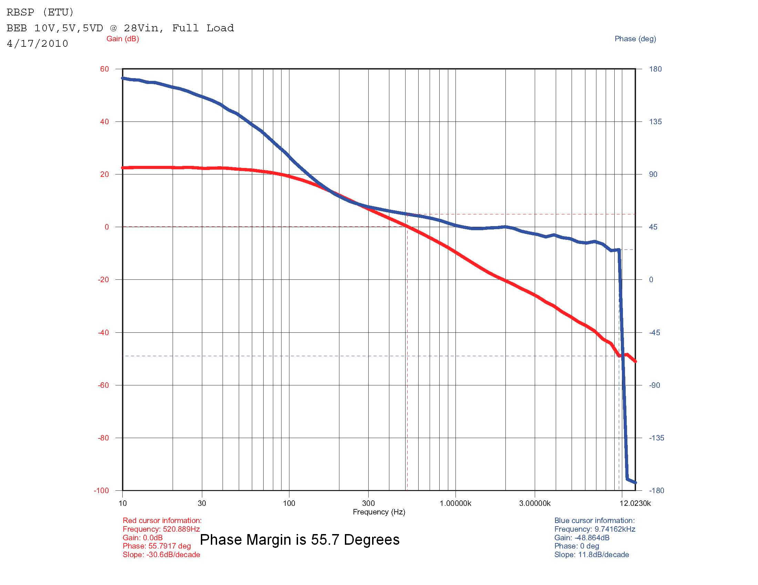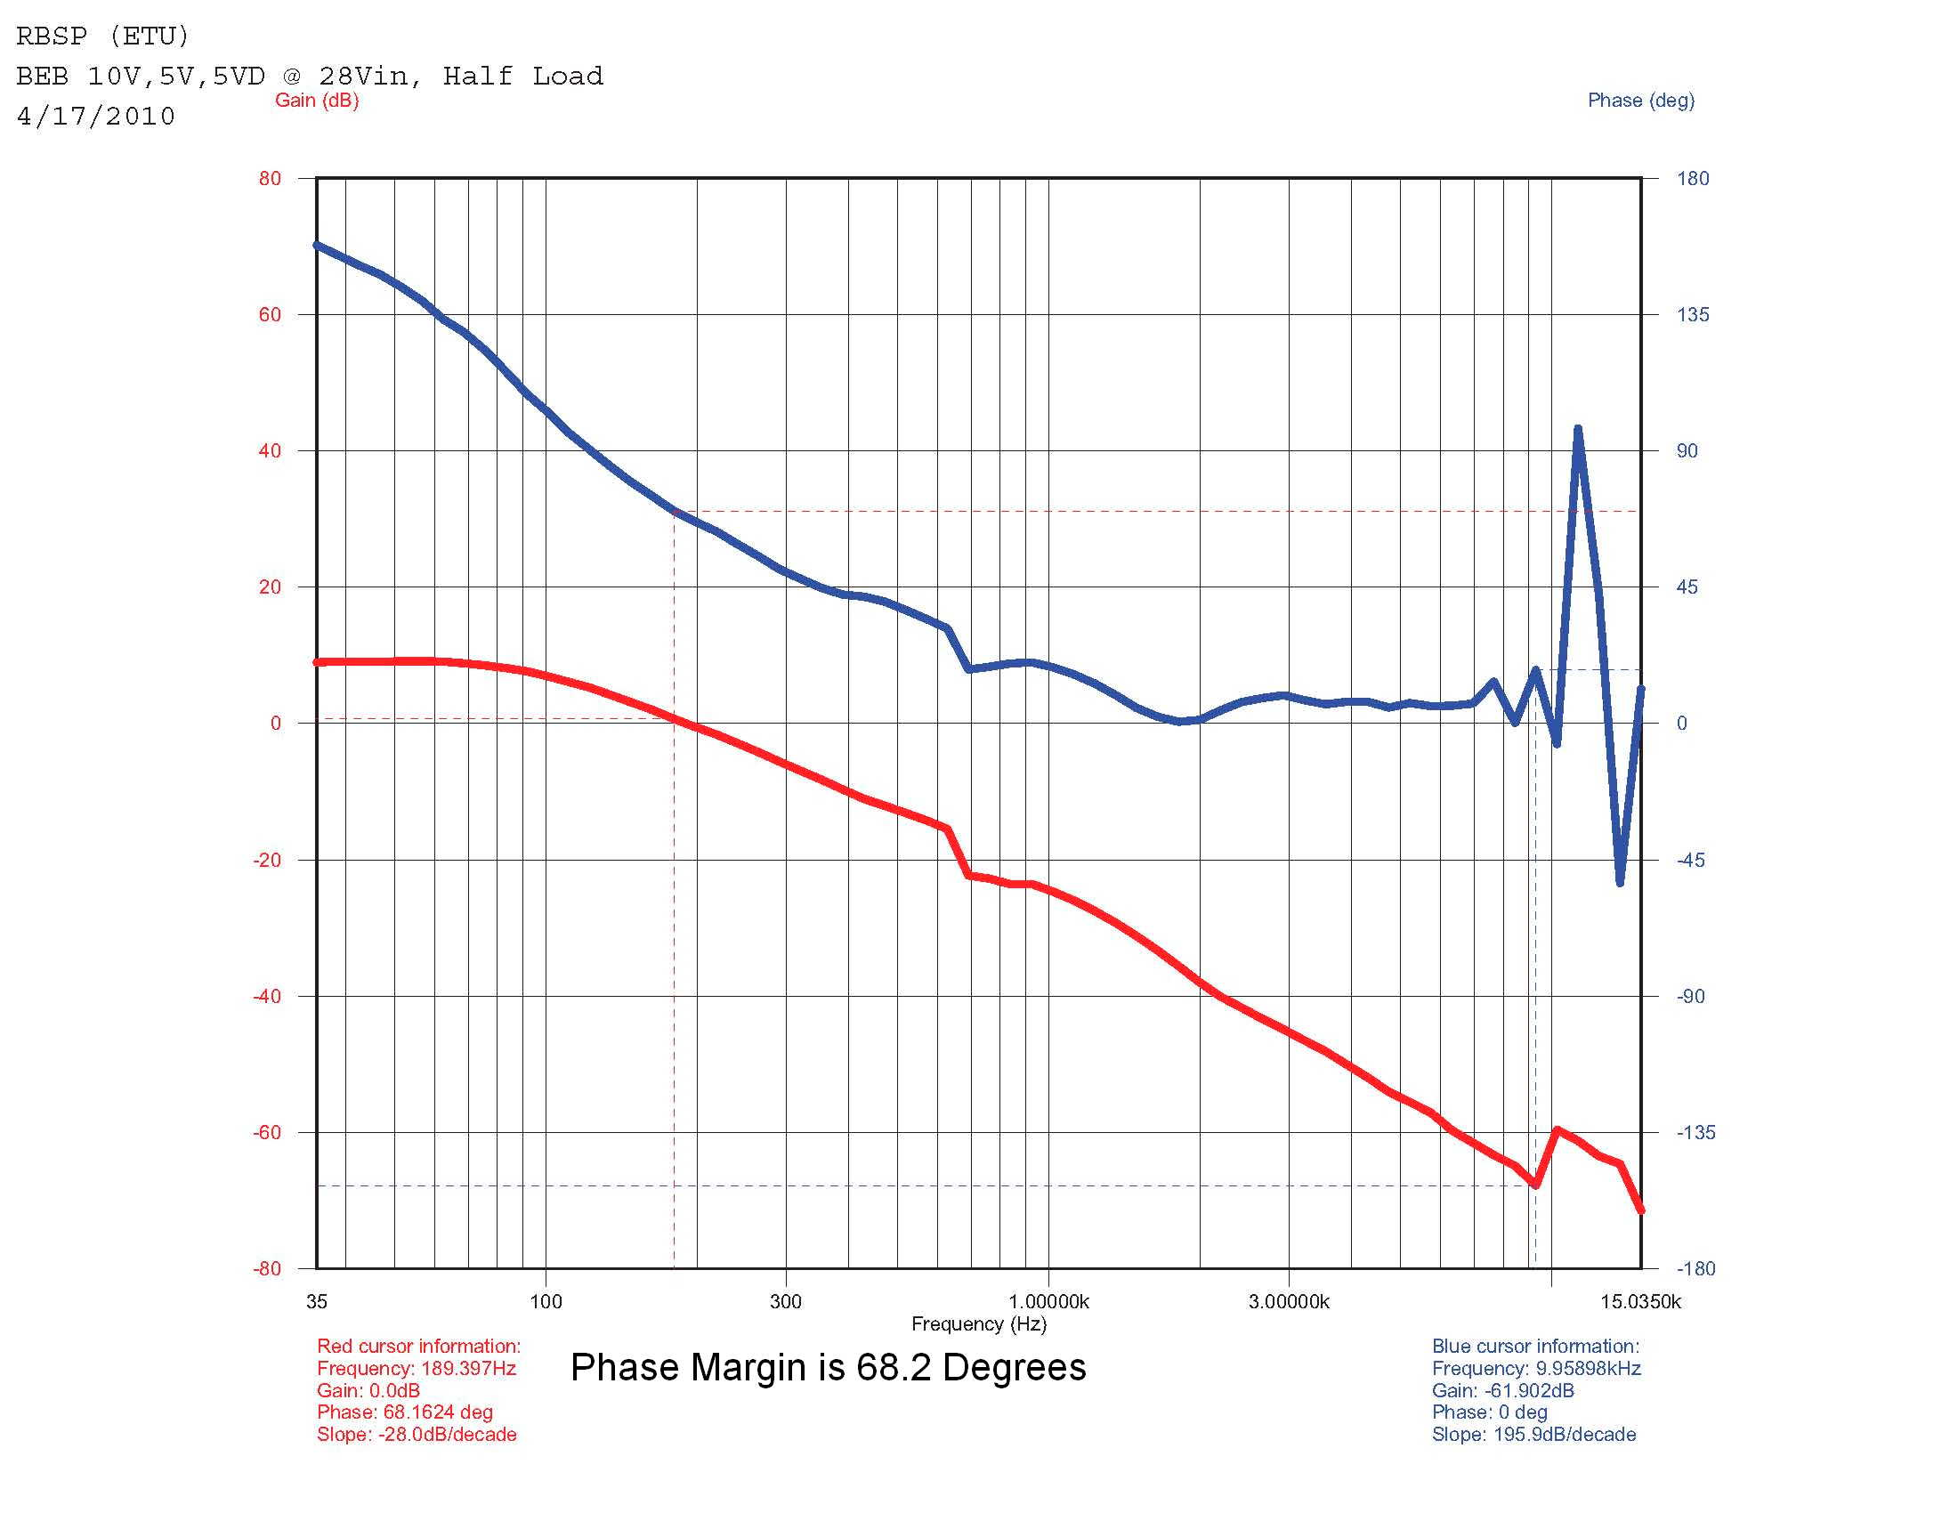
Figure 3 – BEB Supply, full load Figure 4 – BEB Supply, half load

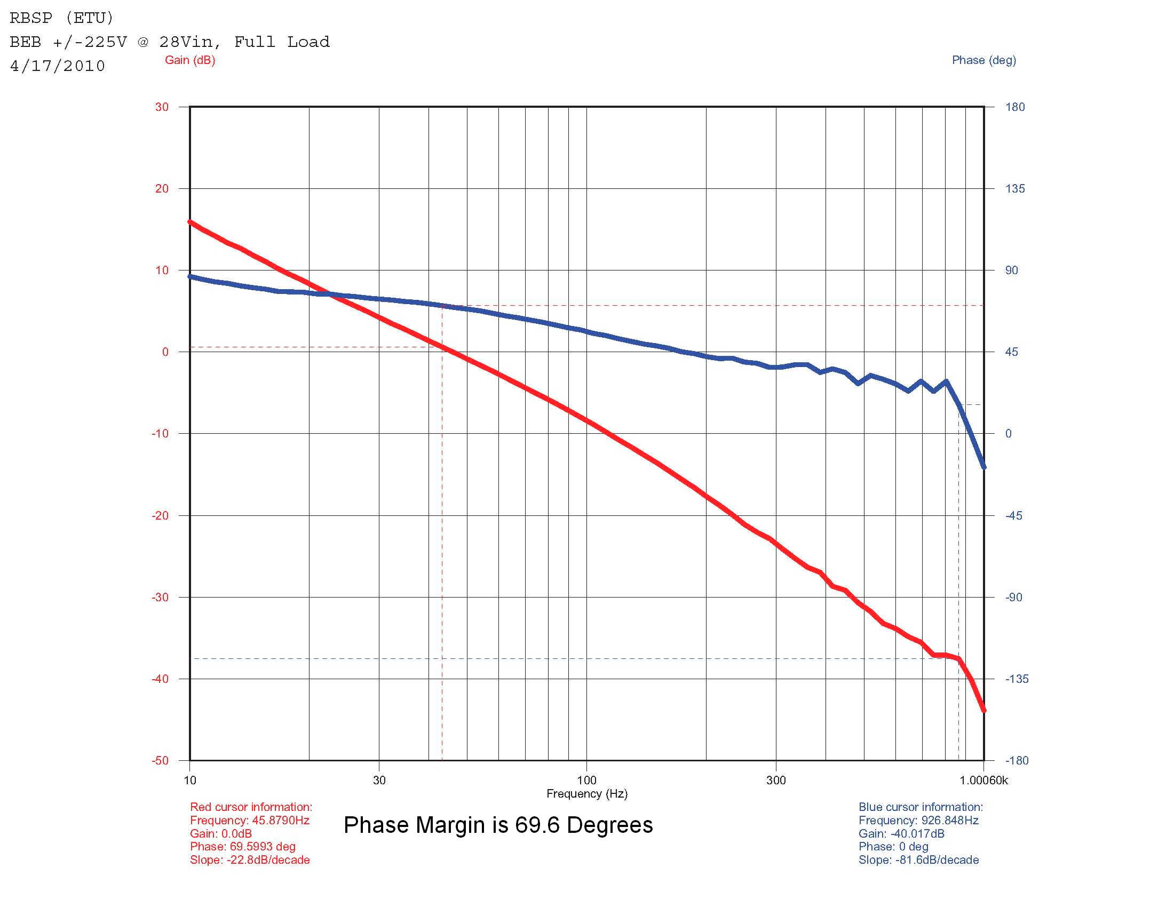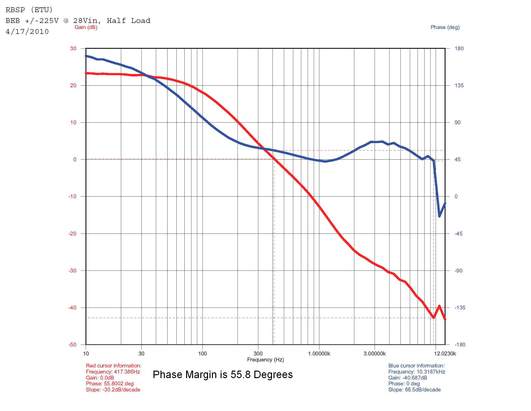
Figure 5 – 225 Supply, Full Load Figure 6 – 225 Supply, Half Load

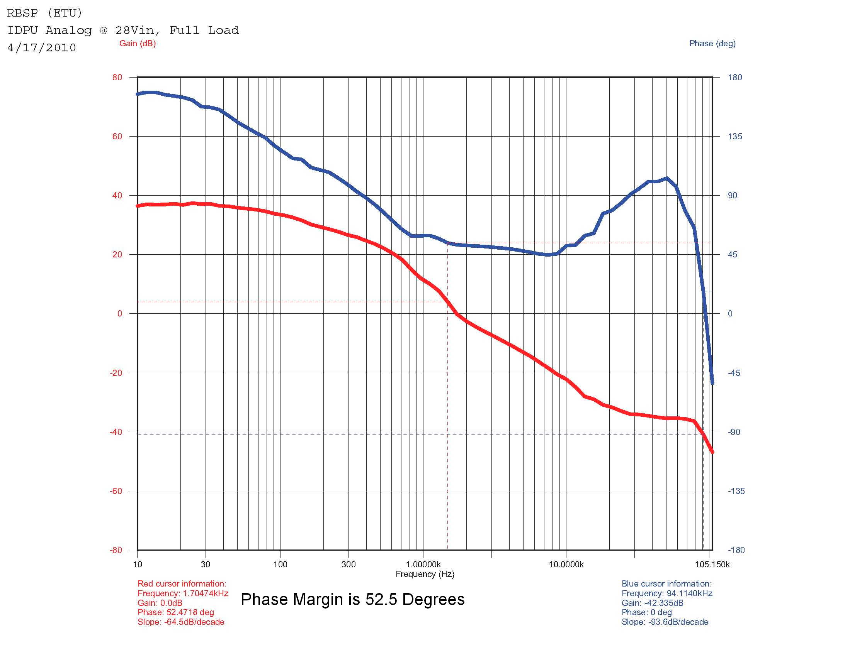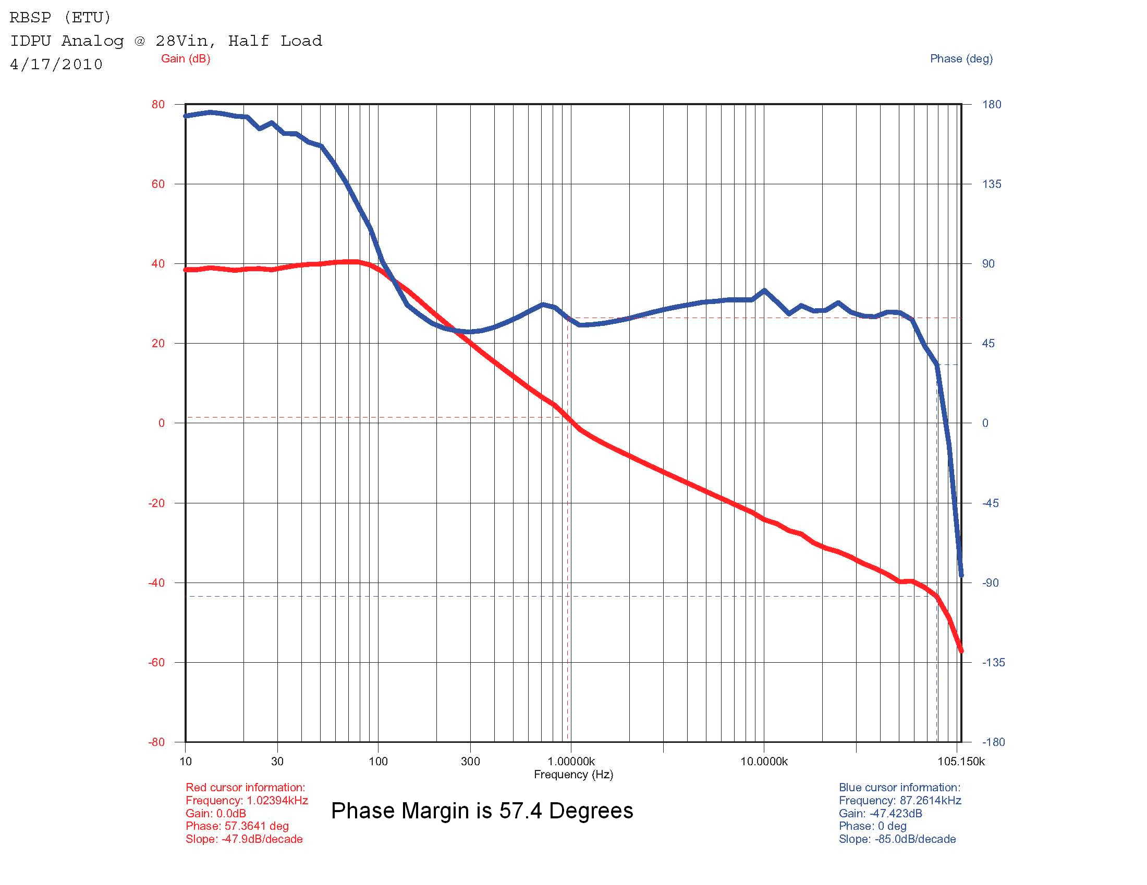
Figure 7 – IDPU Analog, Full Load Figure 8 – IDPU Analog, Half Load

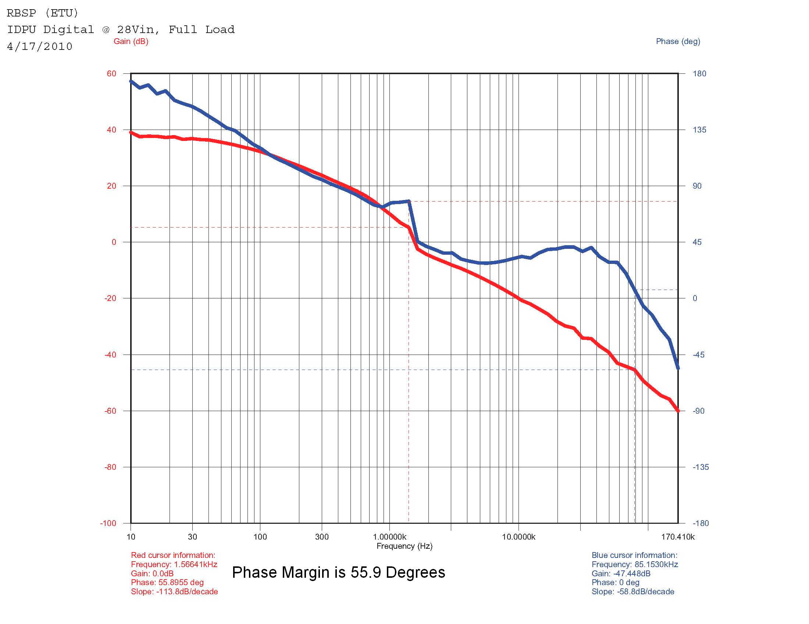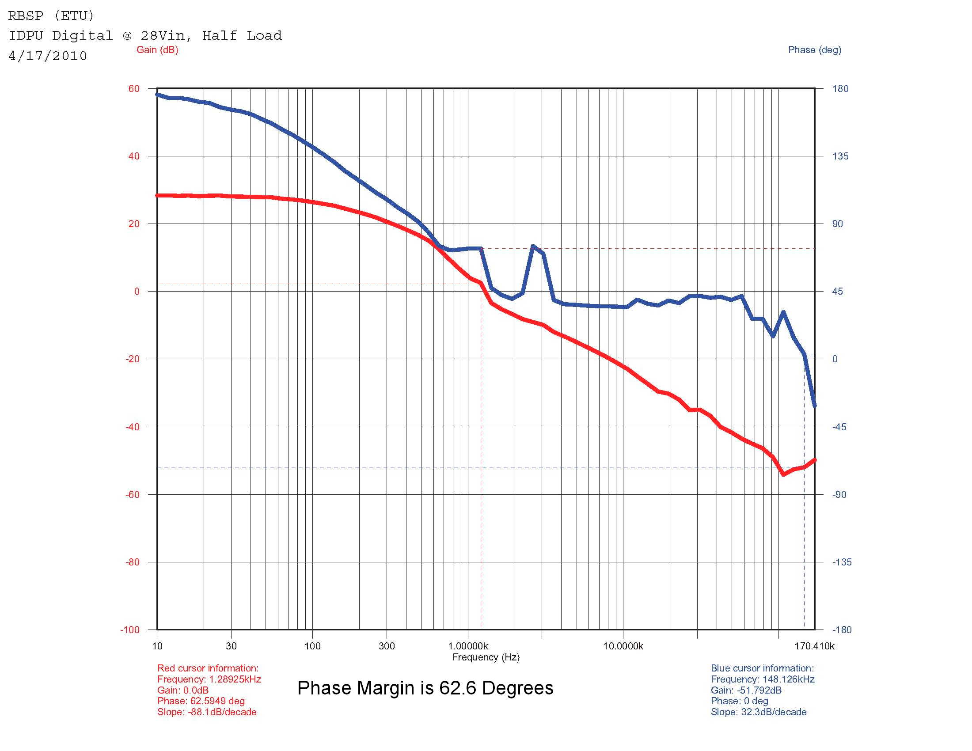
Figure 9 – IDPU Digital, Full Load Figure 10 – IDPU Digital, Half Load

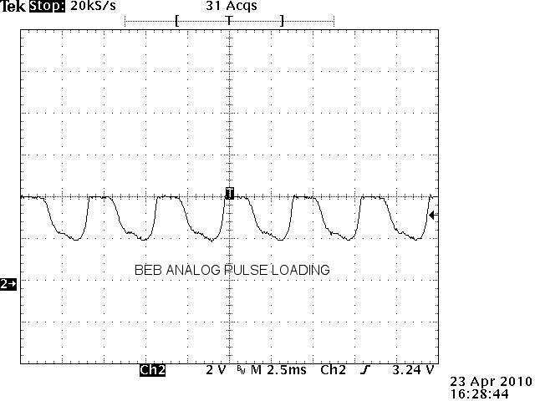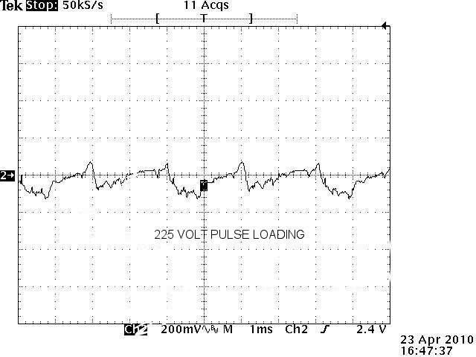
Figure 11- BEB Analog Pulse Loading Figure 12 – 225 V Pulse Loading

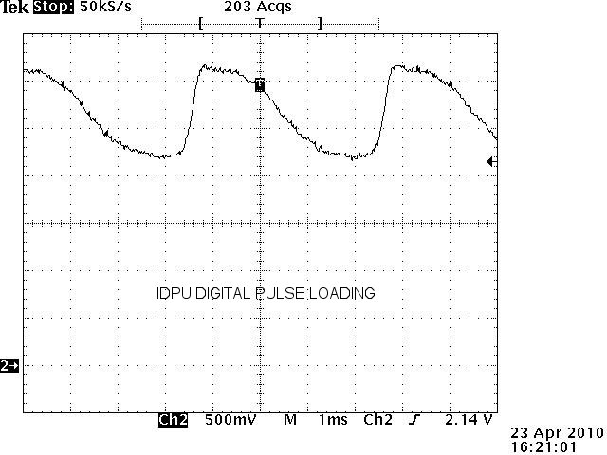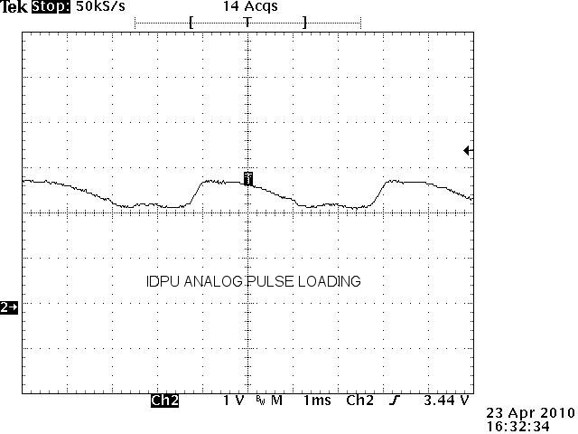
Figure 13 – IDPU Digital Pulse Laoding Figure 14 – IDPU Analog Pulse Loading

Conclusions

Since the pulse loads are smooth without signs of oscillation, and the BODE plots show phase margins greater than the minimum of 45° and close to or exceeding the normally recognized 60°, the supplies are stable for all configurations tested.

