RBSP EFW
Opamp AD822 TID
Test Report

RBSP_EFW_TR_011

David Curtis, U.C. Berkeley RBSP EFW Systems Engineer

Document Revision Record
Rev. | Date | Description of Change

Distribution List
Name | Email
David Curtis, Systems  Keith Goetz, PM  John Bonnell, Inst CoI  Jane Hoberman, BEB EE  Ron Jackson, QA | dwc@ssl.berkeley.edu  goetz@umn.edu  jbonnell@ssl.berkeley.edu  jch@ssl.berkeley.edu  ronj@ssl.berkeley.edu

TBDs
Identifier | Description

Reference Documents
Ref | Doc Number | Title

Overview
A Total Ionizing Dose radiation test was performed for the RBSP EFW project on five AD822AN (Lot Date Code 0847) opamps at National Semiconductor Gamma cell 220 radiation facilities in Santa Clara, CA, on September 10, 2009. Opamps were tested at 13 and 20 krads (Si), and after 24 hour room temperature anneal, and finally after a 168 hour at 100C biased anneal. Some parametric changes were seen during test (particularly at 20krads), most of which were reversed by anneal. All devices were in spec post-anneal except some small exceeedances of the bias current spec.

Test Procedure
The devices were characterized prior to radiation and immediately after each dose (and after the anneal periods) using the opamp characterization setup described in section 2.1. The units were biased during dosing at +/-10V (20mA limit) using the circuit shown in Figure 1. The 5 parts were radiated simultaneously, and the total supply current was monitored during the test – aome increase in current was seen corresponding to the measured supply current increase in the post-test data. Parts were dosed at a rate of 156 rads/sec.

Figure 1 – Biasing circuit

Opamp Characterization
At each step in testing the opamps were fully characterized using an LTS2020 test station with an LTS2100 Opamp family board and an LTS0614 low leakage socket adapter (calibrated Test Tech, 5/21/2008). This test station makes the following measurements (with the listed accuracies) and verifies the results are within the data sheet specifications. The values of the parameters are also recorded to look for any significant charges.

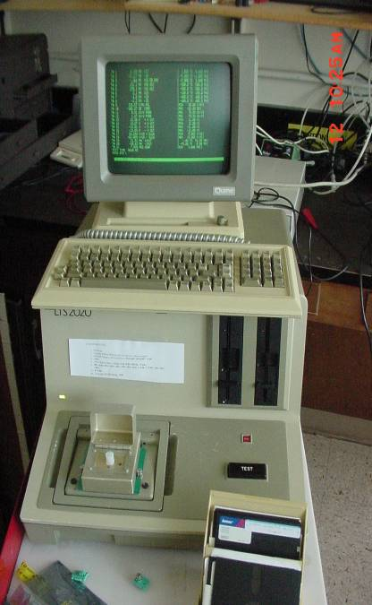
Test 1. V+ supply operating current
Figure 7. LTS2020 OPAMP Tester
±0.2% + 10μA
Test 2. V- supply operating current
±0.2% + 10μA
Test 3,4. Offset voltage
±0.25% + 5μV
Test 5,6,7,8. Bias Current
±5% + 25fA
Test 9,10. Offset Current
±5% + 25fA
Test 11,12. Large Signal Voltage Gain
±1.5% + 1V/mV
Test 13,14. Common Mode Rejection Ratio
±0.25% + 0.1dB
Test 15,16. Power Supply Rejection Ratio
±0.25% + 1μV/V
Test 9,10,11,12. Output Voltage Swing, 10kohm load
±0.4% + 1mV
Test 13,14,15,16. Slew Rate
±10%
Test 17,18. Gain Bandwidth Product.
±10% + 10kHz

Appendix A includes part of the AD822 data sheet showing the operating limits for comparison.

A control part (unit C1) was measured prior to measurements of the TID test devices to verify that any change is not a result of a change in the LTS2020. Each unit was measured twice. All testing was done at room temperature.

The tester was initially set to measure within the data sheet limits. When a parameter exceeded those limits, the limits were expanded in order to measure the actual value without saturation.

Test Results
The units were all in spec prior to radiation dosing. Some parametric changes were seen, particularly on IB. After 13krads IB, IS, and VOS were out of data sheet spec but within acceptable ranges for the RBSP EFW application. After 20krads the parts still operated but were even further out of spec, now out of spec for PSRR and Vout. Vout was sufficiently bad to not meet the RBSP EFW requirements. After 24 hours room temperature anneal the parts were still out of spec but better. Vout was still marginal for RBSP EFW needs. After the 168h 100C anneal the parts were all returned to within spec except for IB, which was slightly out of spec for some parts but well within acceptable limits for RBSP EFW use.

Detailed measurement results are presented in Appendix B.

Appendix A – AD822 Data Sheet

Appendix B - AD822 Test Results

