RBSP EFW
AD648 DDD Test
Test Report

RBSP_EFW_TR_003

David Curtis, U.C. Berkeley RBSP EFW Systems Engineer

Document Revision Record
Rev. | Date | Description of Change

Distribution List
Name | Email
David Curtis, Systems  Keith Goetz, PM  John Bonnell, Inst CoI  Jane Hoberman, BEB EE  Ron Jackson, QA | dwc@ssl.berkeley.edu  goetz@umn.edu  jbonnell@ssl.berkeley.edu  jch@ssl.berkeley.edu  ronj@ssl.berkeley.edu

TBDs
Identifier | Description

Reference Documents
Ref | Doc Number | Title
[1] | RBSP_EFW_SYS_001 | EFW Requirements Matrix
[2] | 7417-9018 | RBSP EME requirements

Overview
The RBSP EFW IDPU DFB board contains the EMFISIS MAG and MSC receive buffer amplifiers (see figure 1). These amplifiers provide differential receivers for each of the MAG and MSC signals from EMFISIS. The inputs of these amplifiers may be subjected to Deep Dielectric Discharge (DDD) generated in the harnesses from EMFISIS. This test is to verify that the amplifier (and in particular the opamp) can survive in the DDD environment of the RBSP mission, as described in reference [2], without additional protection (such as C221, C222 in Figure 1). The DDD model for discharges from insulators onto signals includes a 3pF capacitor charged to 900V, discharging to the signal via 1500ohm (see figure 2 extracted from reference [2]). A conservatively high number of discharges over the life of the mission is ~1000.

The candidate opamp used in the EMFISIS buffer amplifier is the AD648SQ/883 (see Appendix A for a datasheet). The part has ESD input protection circuitry, so we expect it will survive DDD events.

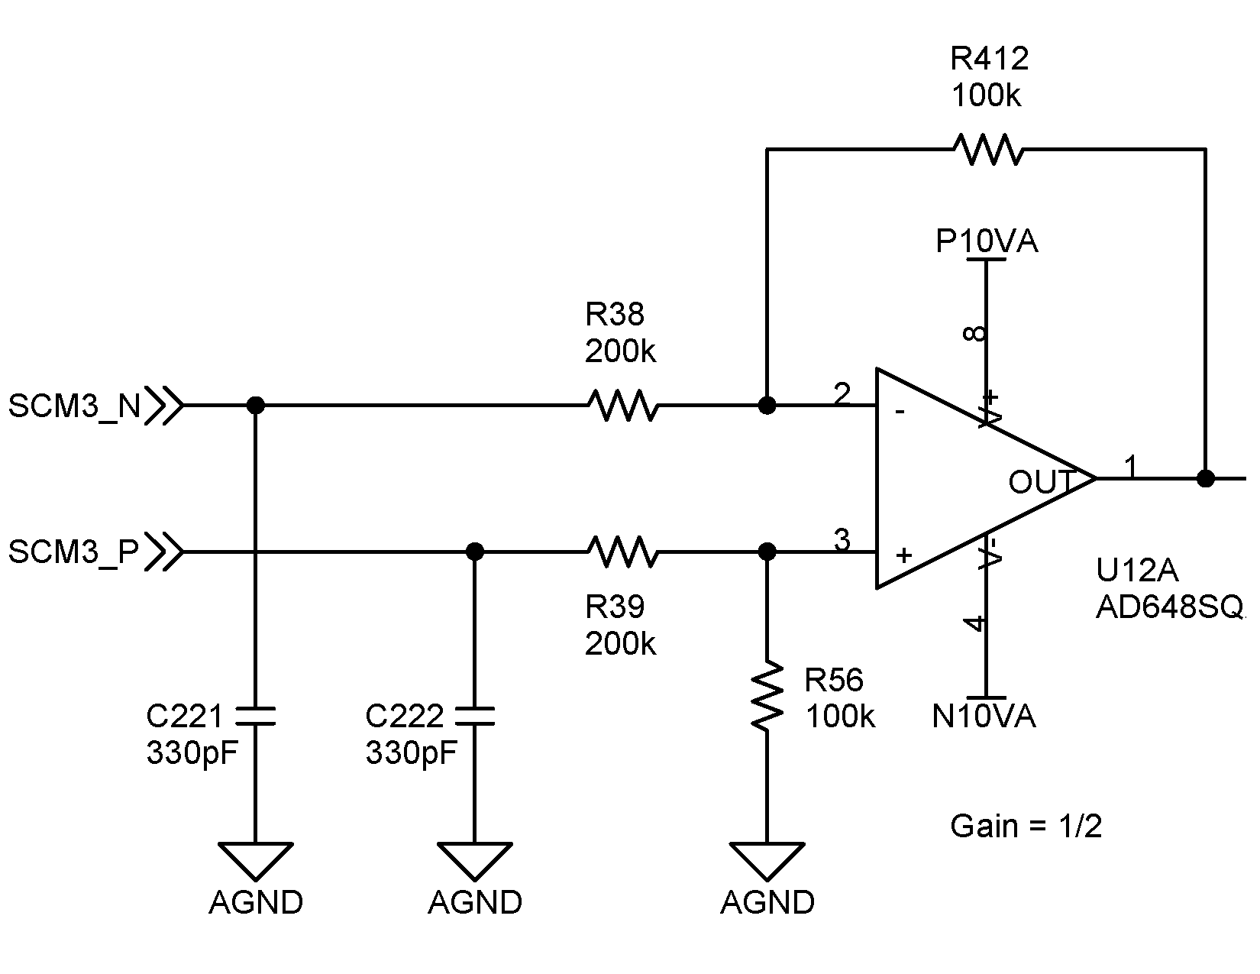

Figure 1. EMFISIS receive buffer schematic

Figure 2. DDD model (from insulator) – from ref 2 fig 3.1.1-1 a.

Test Procedure
The plan is to verify that the AD648 opamp is immune to damage from DDD events in the harness. This shall be done by generating simulated discharges into the input and output pins of an AD648 opamp, first an ETU part, then a part from the LASP DFB flight lot (AD648SQ/883, D/C 0125). The AD648 is tested in a ZIF socket with bypass capacitors on the power supply lines to a ground reference for the DDD event simulator (Figure 4). The bypass capacitors are equivalent to what is on the flight preamp, to provide a similar transient current flow. The AD648 is tested both biased (+/-10V, as for flight) and unbiased. No other parts or harness is attached to the AD648; these other parts will tend to mitigate the transient currents, so testing without them is considered worst case. Testing will be done at +1500V and -1500V (>50% margin over the DDD event model).

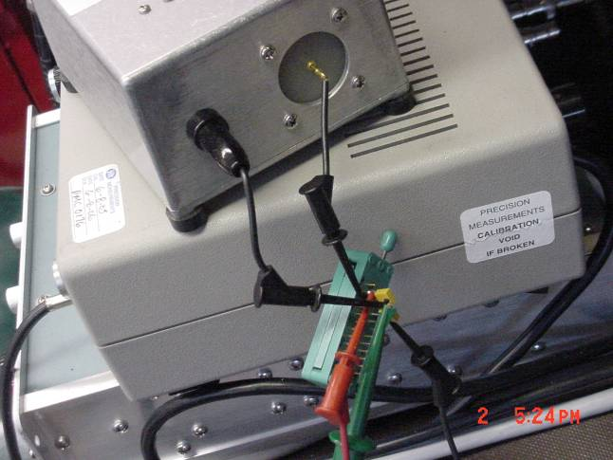 Figure 4. AD648 Test Socket

DDD Tester
A custom DDD tester was developed at SSL. It generates a series of simulated DDD pulses of programmable voltage. Figure 5 is a schematic of the tester. Note that it has 10pF capacitance to provide margin on the test, and to reduce the effects of stray capacitance in the tester. In addition, a HV supply, a pulse generator (to run the relay) and a counter were used as shown in Fig 6. The unit was calibrated against capacitive and resistive loads to verify performance.

Figure 5. DDD Tester schematic

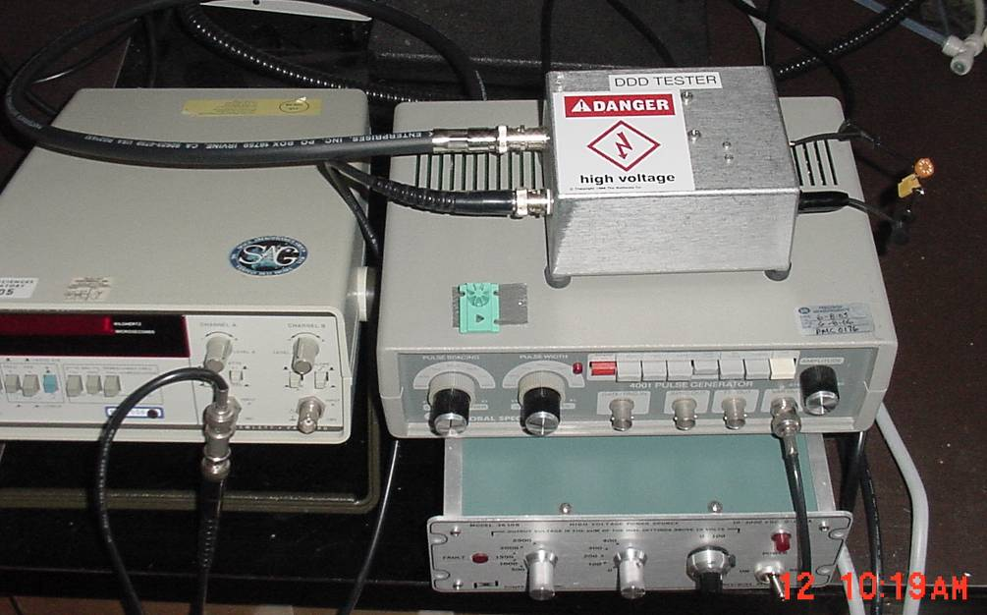
Figure 6. DDD Test setup

Opamp Characterization
Prior to DDD testing and between DDD tests the AD648 was fully characterized using an LTS2020 test station with an LTS2100 Opamp family board and an LTS0322 low leakage socket adapter (calibrated Test Tech, 5/21/2008). This test station makes the following measurements (with the listed accuracies) and verifies the results are within the data sheet specifications. The values of the parameters are also recorded to look for any significant changes.

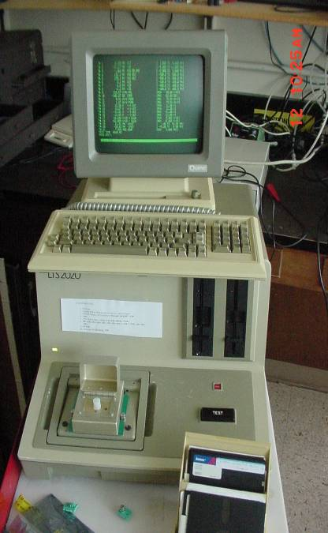
Test 1. V+ supply operating current
Figure 7. LTS2020 OPAMP Tester
±0.2% + 10μA
Test 2. V- supply operating current
±0.2% + 10μA
Test 3. Offset voltage
±0.25% + 5μV
Test 4,5 Bias Current
±5% + 25fA
Test 6. Large Signal Voltage Gain
±1.5% + 1V/mV
Test 7. Common Mode Rejection Ratio
±0.25% + 0.1dB
Test 8,9. Output Voltage Swing, 10kohm load
±0.4% + 1mV
Test 13,14. Output current source/sink
±0.2% + 10μA
Test 10,11. Slew Rate
±10%
Test 12. Gain Bandwidth Product.
±10% + 10kHz

Appendix A includes part of the AD648 data sheet showing the operating limits for comparison.
A control part was measured between measurements of the DDD test device to verify that any change is not a result of a change in the LTS2020. All testing was done at room temperature.

Test Results
Units E1 and E2 are non-flight parts, AD648JN, LDC 9828. Unit F1 is from the LASP flight parts lot, AD648SQ/883 LDC 0125. Test results are shown in the tables in Appendix B, C, and D. All measurements are in spec. Measurements highlighted are >2.5 sigma from the mean, and are typically tester transients.

Unit E1.
This part was not exposed to DDD, but was used as the control to verify the test station operation between measurements of parts exposed to the DDD tester. Results are shown in Appendix B.

Unit E2.
Tests were performed first unbiased then biased at +/-10V. ~1000 DDD pulses of +1500V and -1500V were applied to each of the –IN (pin 2), +In (pin 3) and OUT (pin 1) signals. The opamp was characterized between each set of tests, as shown in Appendix C. No significant changes in the opamp performance was seen, and all measurements were in spec.

Unit F1.
Tests were performed first unbiased then biased at +/-10V. ~1000 DDD pulses of +1500V and -1500V were applied to each of the –IN (pin 2), +In (pin 3) and OUT (pin 1) signals of the first amplifier in the package, and the –IN (pin 6), +In (pin 5) and OUT (pin 7) signals of the second amplifier in the package. The opamp was characterized between each set of tests, as shown in Appendix D. No significant changes in the opamp performance was seen, and all measurements were in spec.

The part in this configuration is considered qualified for flight with no DDD input protection parts required.

Appendix A – AD648 Data Sheet

Appendix B - AD648 Unit E1 (Control) Test Results

Appendix C - AD648 Unit E2 Test Results

Appendix D - AD648 Unit F1 Test Results

