RBSP EFW
Preamp HA5127 DDD Test
Test Report

RBSP_EFW_TR_002

David Curtis, U.C. Berkeley RBSP EFW Systems Engineer

Document Revision Record
Rev. | Date | Description of Change

Distribution List
Name | Email
David Curtis, Systems  Keith Goetz, PM  John Bonnell, Inst CoI  Jane Hoberman, BEB EE  Ron Jackson, QA | dwc@ssl.berkeley.edu  goetz@umn.edu  jbonnell@ssl.berkeley.edu  jch@ssl.berkeley.edu  ronj@ssl.berkeley.edu

TBDs
Identifier | Description

Reference Documents
Ref | Doc Number | Title
[1] | RBSP_EFW_SYS_001 | EFW Requirements Matrix
[2] | 7417-9018 | RBSP EME requirements

Overview
The RBSP EFW IDPU BEB board contains the EMFISIS buffer amplifiers (see figure 1). These amplifiers takes the Vsphere signal from two opposing boom units and generates the difference signal, which is provided to the EMFISIS instrument. The inputs and outputs of this amplifiers may be subjected to Deep Dielectric Discharge (DDD) generated in the harnesses to the boom units and EMFISIS. This test is to verify that the amplifier (and in particular the opamp) can survive in the DDD environment of the RBSP mission, as described in reference [2], without additional protection (such as C4 in Figure 1). The DDD model for discharges from insulators onto signals includes a 3pF capacitor charged to 900V, discharging to the signal via 1500ohm (see figure 2 extracted from reference 2). A typical number of discharges over the life of the mission is ~1000.

The candidate opamp used in the EMFISIS buffer amplifier is the HA5127/883 (see Appendix A for a datasheet). This is a bipolar opamp with an ESD rating of 2,000V, so we expect it will survive DDD events.

Figure 1. EMFISIS buffer schematic

Figure 2. DDD model (from insulator) – from ref 2 fig 3.1.1-1 a.

Test Procedure
The plan is to verify that the HA5127 opamp is immune to damage from DDD events in the harness. This shall be done by generating simulated discharges into the input and output pins of an HA5127/883 opamp from the potential flight lot (HA7-5127/883, D/C H0231AE). The HA5127 is tested in a ZIF socket with bypass capacitors on the power supply lines to a ground reference for the DDD event simulator (Figure 4). The bypass capacitors are equivalent to what is on the flight preamp, to provide a similar transient current flow. The HA5127 is tested both biased (+/-10V, as for flight) and unbiased. No other parts or harness is attached to the HA5127; these other parts will tend to mitigate the transient currents, so testing without them is considered worst case. Testing will be done at +1500V and -1500V (>50% margin over the DDD event model).

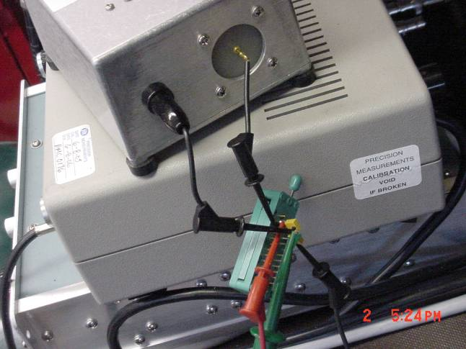 Figure 4. HA5127 Test Socket

DDD Tester
A custom DDD tester was developed at SSL. It generates a series of simulated DDD pulses of programmable voltage. Figure 5 is a schematic of the tester. Note that it has 10pF capacitance to provide margin on the test, and to reduce the effects of stray capacitance in the tester. In addition, a HV supply, a pulse generator (to run the relay) and a counter were used as shown in Fig 6. The unit was calibrated against capacitive and resistive loads to verify performance.

Figure 5. DDD Tester schematic

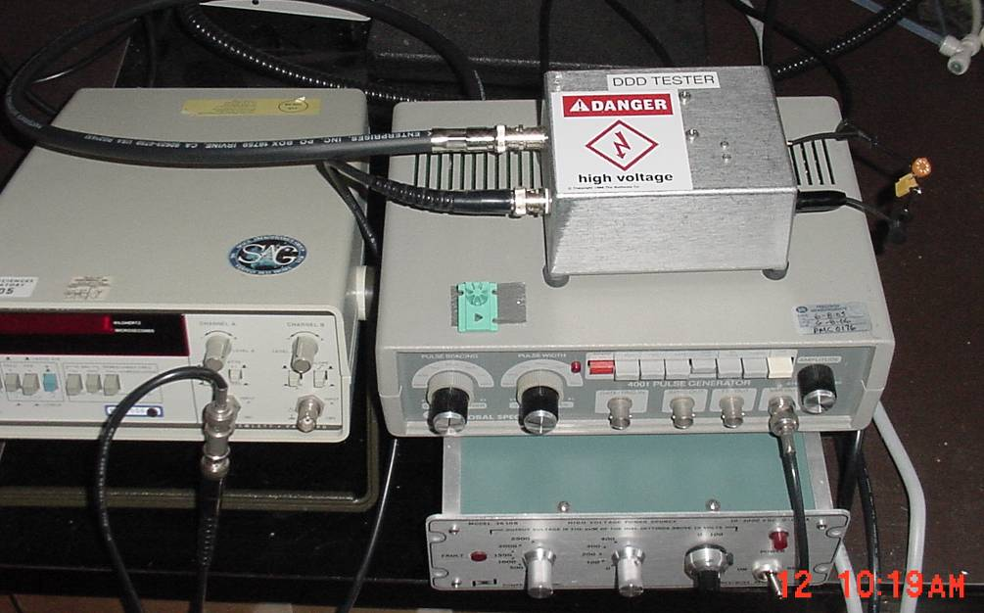
Figure 6. DDD Test setup

Opamp Characterization
Prior to DDD testing and between DDD tests the HA5127 was fully characterized using an LTS2020 test station with an LTS2100 Opamp family board and an LTS0614 low leakage socket adapter (calibrated Test Tech, 5/21/2008). This test station makes the following measurements (with the listed accuracies) and verifies the results are within the data sheet specifications. The values of the parameters are also recorded to look for any significant charges.

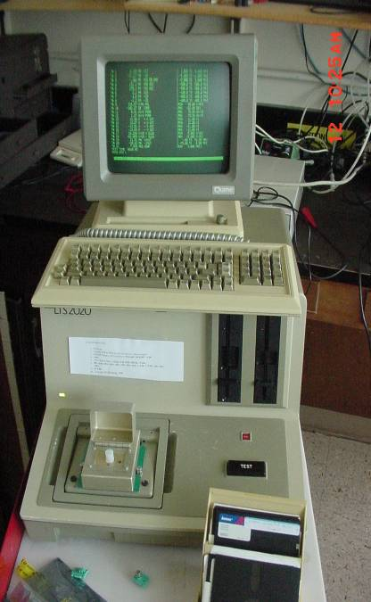
Test 1. V+ supply operating current
Figure 7. LTS2020 OPAMP Tester
±0.2% + 10μA
Test 2. V- supply operating current
±0.2% + 10μA
Test 3. Offset voltage
±0.25% + 5μV
Test 4. Offset Current
±5% + 25fA
Test 5. Bias Current
±5% + 25fA
Test 6. Large Signal Voltage Gain
±1.5% + 1V/mV
Test 7. Common Mode Rejection Ratio
±0.25% + 0.1dB
Test 8. Power Supply Rejection Ratio
±0.25% + 1μV/V
Test 9,10. Output Voltage Swing, 2kohm load
±0.4% + 1mV
Test 11,12. Output current source/sink
±0.2% + 10μA
Test 13,14. Slew Rate
±10%
Test 15. Gain Bandwidth Product.
±10% + 10kHz

Appendix A includes part of the HA5127 data sheet showing the operating limits for comparison. Note that it was found that a 100pF compensation capacitor was needed between the –IN and OUT pins, to stabilize the part during performance testing.

A control part was measured between measurements of the DDD test device to verify that any change is not a result of a change in the LTS2020. All testing was done at room temperature.

Test Results

Unit 1.
Prior to exposure the part showed better than typical characteristics for an HA5127. This part was not exposed to DDD, but was used as the control to verify the test station operation between measurements of parts exposed to the DDD tester. Results are shown in Appendix B. Note that tests1-16 were used to adjust up the opamp tester (values marked ‘A’ result from instabilities in the test circuit which were solved by adding a 100pF capacitor between –IN and OUT as called out in the opamp datasheet). Measurements highlighted are tester transients.

Unit 2.
Tests were performed first unbiased then biased at +/-10V. ~1000 DDD pulses of +1500V and -1500V were applied to each of the –IN (pin 2), +In (pin 3) and OUT (pin 6) signals. The opamp was characterized between each set of tests, as shown in Appendix C. No changes in the opamp performance was seen.

The part in this configuration is considered qualified for flight

Appendix A – HA5127/883 Data Sheet
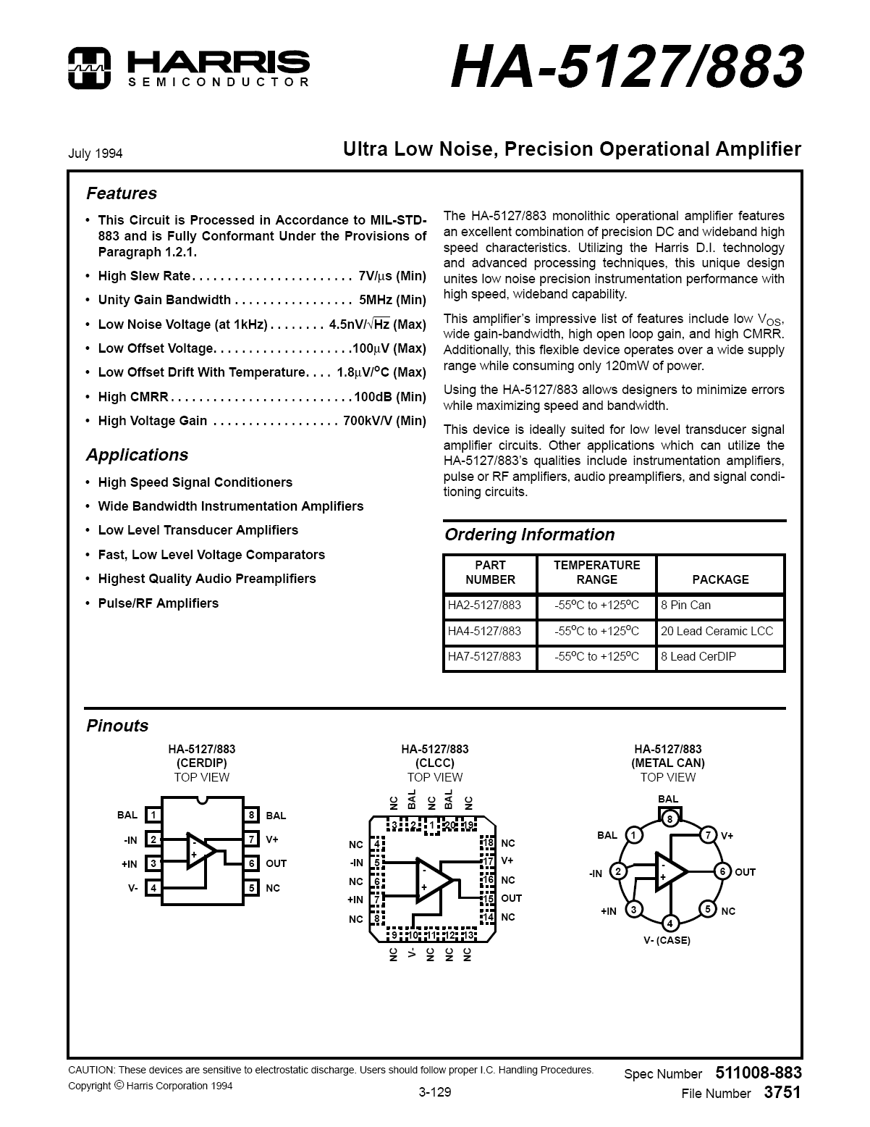

Appendix B - HA5127 Unit 01 (Control) Test Results

Appendix C - HA5127 Unit 02 Test Results

