RBSP-EFW

EFW/EMFISIS Analog Interface Playdate

John Bonnell, 10 May 2010

# EFW Instrument Configuration and Parameters



# 19 August 2010: EFW-EMFISIS Safe-To-Mate, EMFISIS-MSC to EFW, EMFISIS-MAG to EFW, EFW to EMFISIS-E-field.

; 20090819\_145025\_UUT2\_EMFISIS\_mag\_interface

; 20090819-215000 to 20090819-233300.

; active MAG excitation:

; 215345 to 220545.

; MAG disconnected (?):

; 220545 to 233000.

Available APIDs: 0x243, 244, 245 (SVY); 0x246, 247, 248 (B1); 0x249, 24a, 24b (B2).

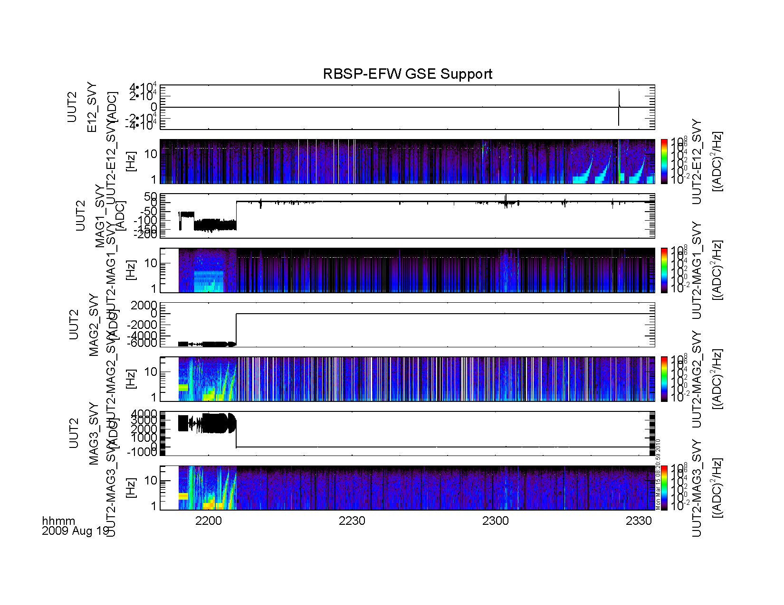

Figure 1: EMF-MAG Interface Summary Plot (rb\_efw\_etu\_20090819\_summary\_001).

Figure 1 shows waveform and spectral data taken during the 19 Aug 2009 interface testing period. The data are shown in ADC units (aka. counts) for each channel, and can be converted to volts at the RBSP-EFW-DFB interface using the conversion factors shown in Table TTT above. The channels included are from the continuous survey mode data, and include the 32 samp/s E12, and 64 samp/s MAG1..3 channels. The plot covers approximately 1-1/2 hours of data taking, from before 2200 UT to 2330 UT (Central Daylight Time = UT – 5 hr), so interval is approximately 1700 to 1830 CDT (late afternoon to early evening).

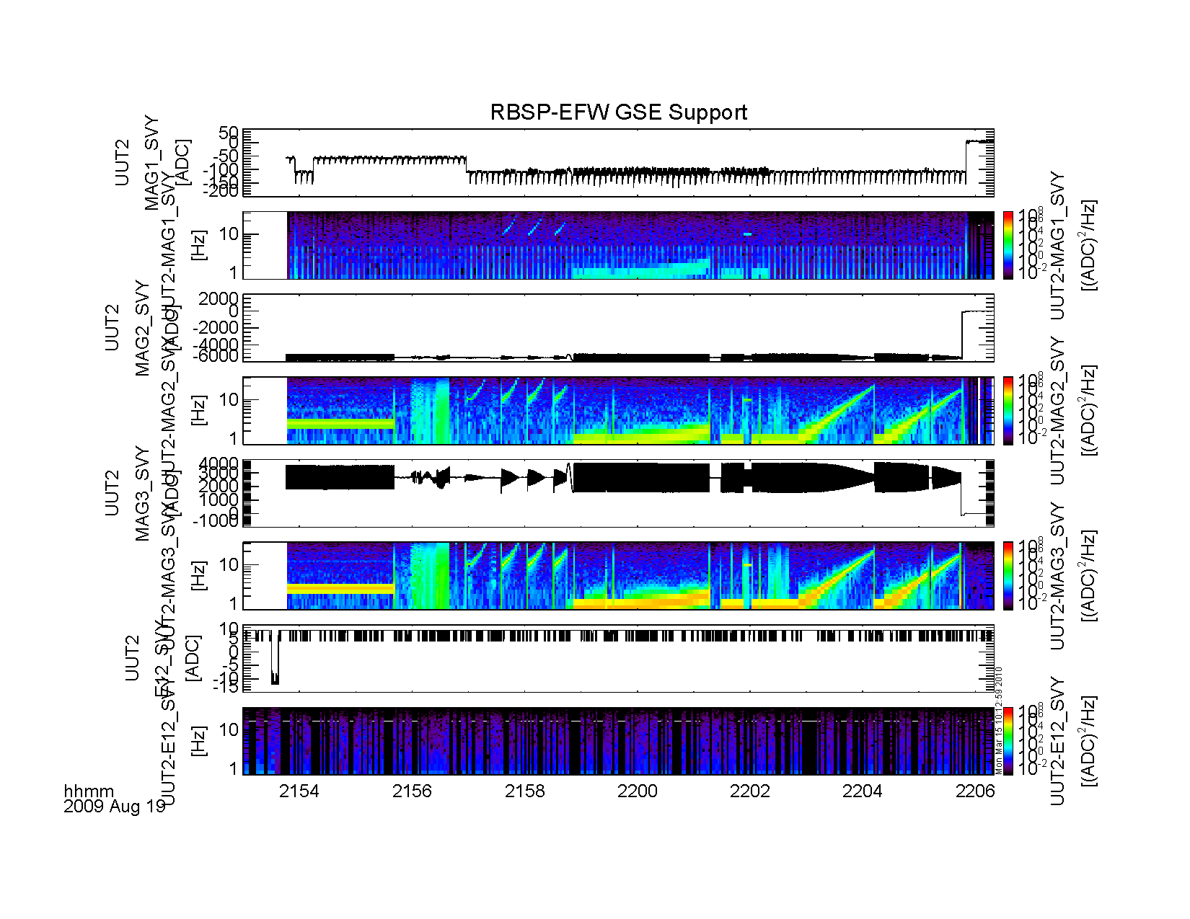

Figure 2: (rb\_efw\_etu\_20090819\_summary\_002).

Figure 2 shows a shorter interval of the same dataset, from around 2153 to 2206 UT, during a time of active MAG excitation.

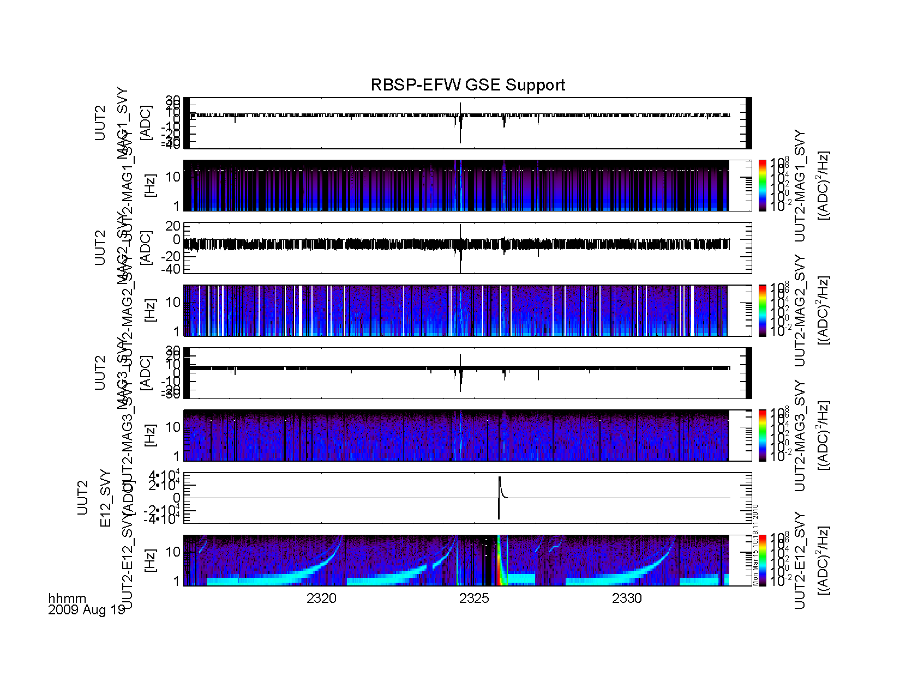

Figure 3: (rb\_efw\_etu\_summary\_003).

Figure 3 shows yet another time interval (2315-2335 UT), this time when the E-field sensor was being stimulated.

## MSC Verification:

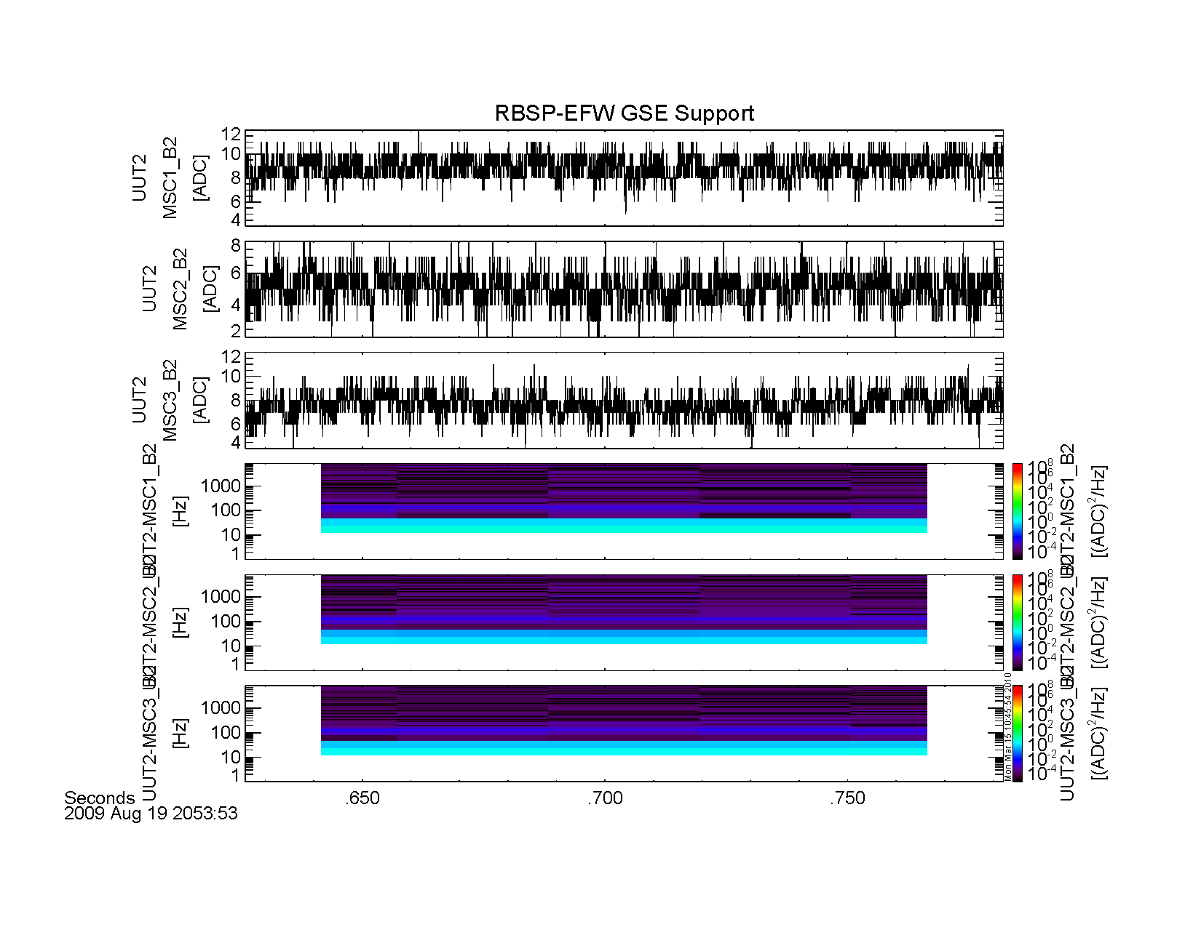

Figure 4: 16384-samp/s EMF MSC data (APID 0x24b) showing noise level in time and spectral domain (rb\_efw\_etu\_summary\_004).

Figure 4 shows waveform and spectral data for the 16-ksamp/s MSC interface during a time when the EMFISIS-MSC sensor was connected, but not being actively excited.

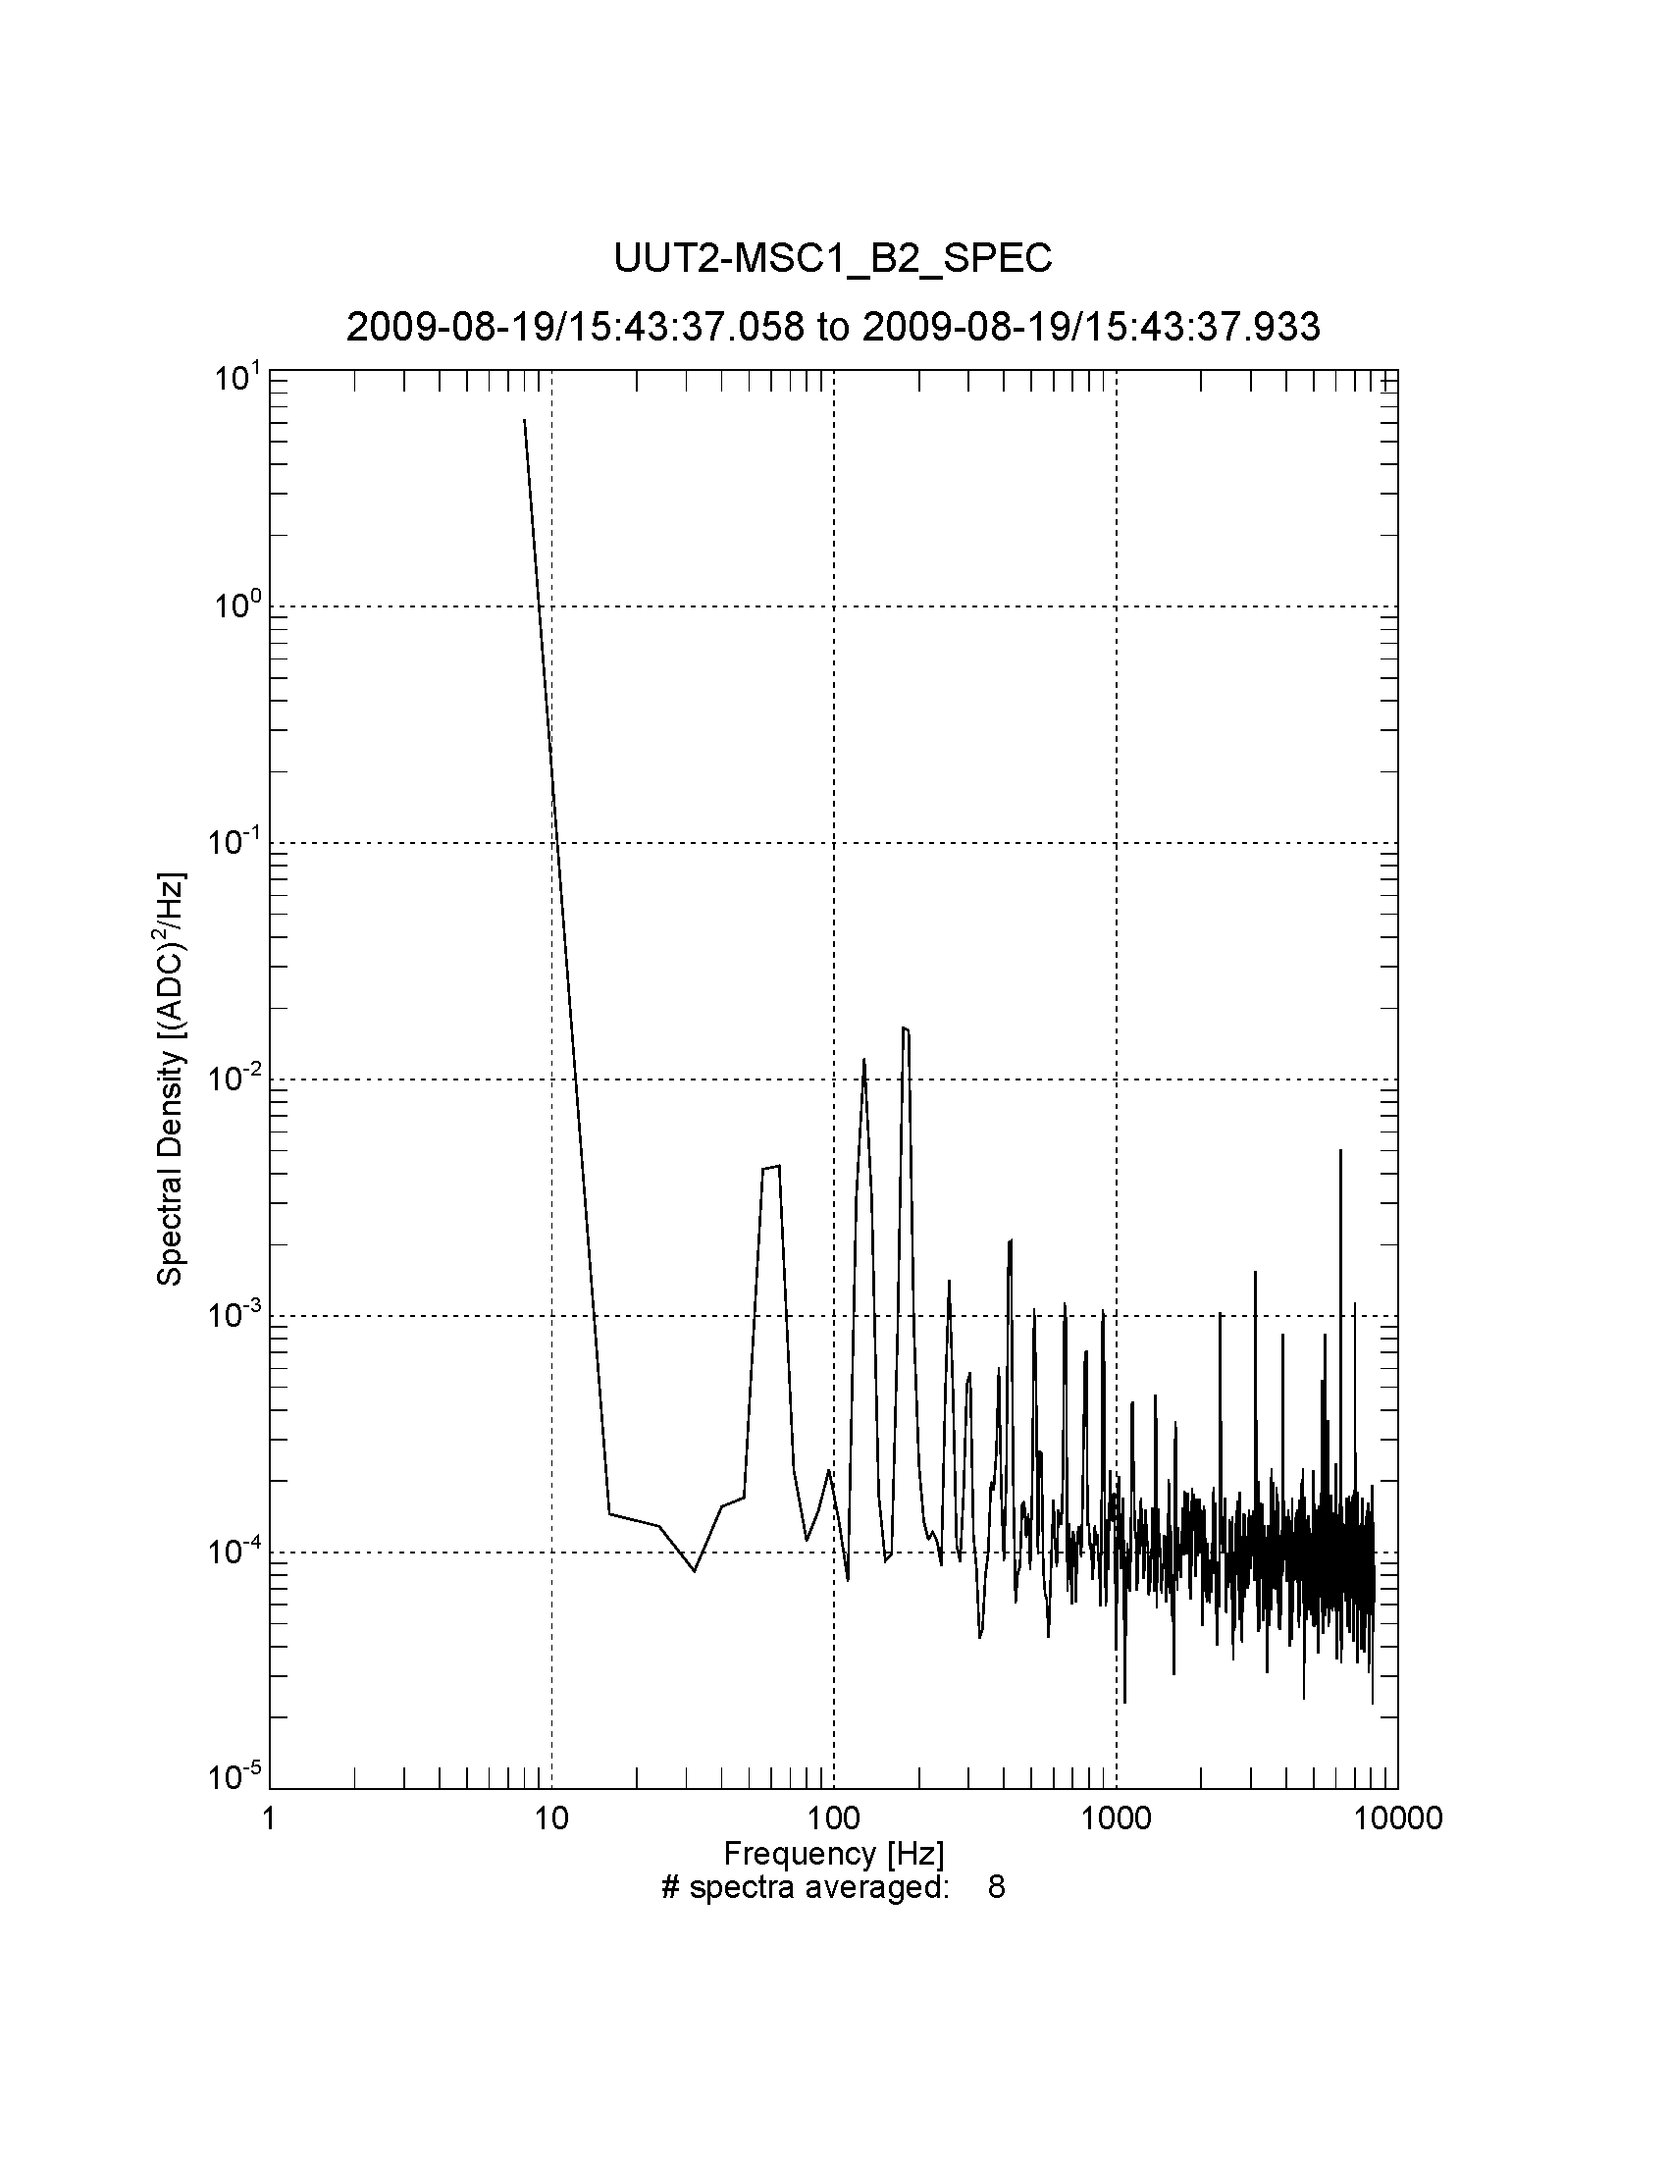

Figure 5:rb\_efw\_msc\_20090819\_154338\_001.

Figure 5 shows an average line spectrum of the MSC channel noise taken over approx. 1 s of time during the interval shown in Figure 4. The quantization noise floor for the channel should be (1/12)(ADC^2)/(16384 Hz) ~ 5e-6 (ADC^2)/Hz, and so the observed continuum noise floor at approx. 10-4 (ADC^2)/Hz represents actual noise in the system, rather than the quantization noise floor. The large peak at 8 Hz is the impact of the finite DC offset in the channel, rather than an actual noise spike. Significant spikes at 60 Hz and harmonics reflect leakage of power line noise into the sensor box or EMFISIS and EFW signal chains. Other, higher frequency lines exist in the spectrum in the 1-10 kHz band; their amplitudes are in the few times 10-4 (ADC^2)/Hz to few times 10-3 (ADC^2/Hz).

The conversion factor from ADC to volts at the MSC interface is 1.53e-4 (V/ADC). The conversion factor from nT at MSC sensor to volts at the MSC interface is ~ 0.7 V/nT, so the conversion factor from ADC to nT is (1.53e-4/0.7) = 2.2e-4 nT/ADC, or 4.8e-8 (nT^2/ADC^2). This means that the observed continuum noise floor corresponds to a noise level at the MSC sensor head of ~5e-12 nT^2/Hz, which is a factor of 10^5 smaller than the required noise level (IPLD-243: noise floor <= 1e-7 nT^2/Hz at 100 Hz). Even the line emissions have spectral densities a factor of 10^4 smaller than the required limit.

These observations suggest that the final Flight MSC interface has a very good chance for meeting the noise floor requirements.

## E and V Channel Verification (EFW internal):

# rb_efw_v1_20090819_154337_001.png

Figure 6: rb\_efw\_v1\_20090819\_154337\_001

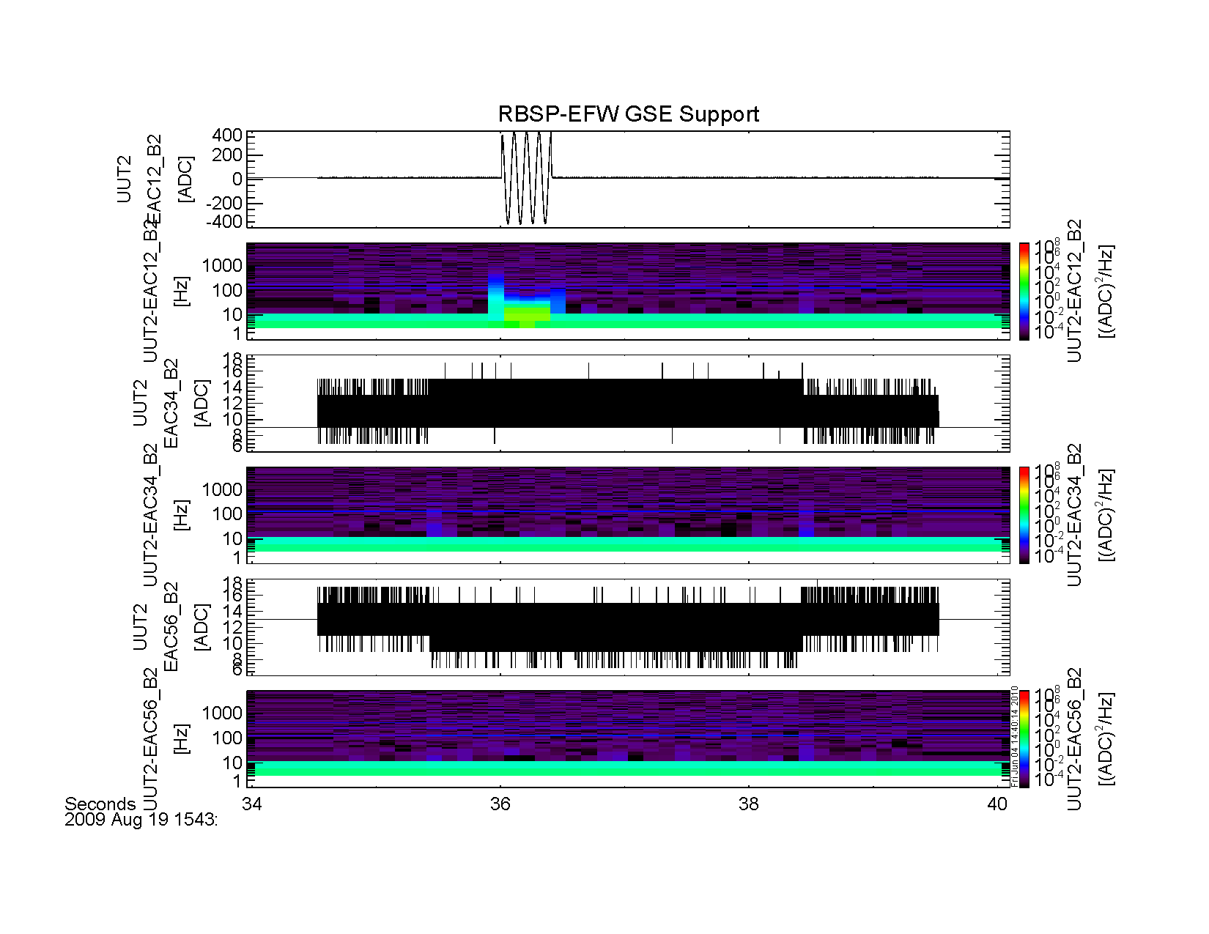

Figure 7:rb\_efw\_etu\_e\_b2\_summary\_20090819\_154334\_001.png

# rb_efw_eac12_20090819_144337_001.png

Figure 13: rb\_efw\_eac12\_20090819\_154337\_001.

## MAG Channel verification:

The noise level requirement on the MAG channel is 2 nT RMS (REQ REFERENCE). Because of the three range states available to the EMFISIS-MAG instrument, this noise level requirement translates to three different requirements on the noise level at input to the EFW DFB. These are collected in TABLE XXX below:

Table 1: Equivalent MAG Channel NTE Noise Levels.

|  |  |  |
| --- | --- | --- |
| **Range State**  **[nT]** | **Conversion Factor**  **[ADC/nT]** | **Noise Level**  **[NTE ADC RMS]** |
| +/- 65,536 | 0.5 | 1 |
| +/- 4096 | 8 | 16 |
| +/- 256 | 128 | 256 |

Test data from both the EFW-EMFISIS Analog I/F Test in Aug 2009, as well as subsequent MAG I/F testing at UCB in May 2010 are included in the supporting data below. It was found (fall 2009) that there was a bug in the EFW DFB FPGA waveform data processing in Fall that led to truncation of low-amplitude data, enhanced noise levels and offsets in the waveform channels at less than the 16,384-samp/s rates, that led to the higher-than expected noise floors in the Aug 2009 data. The test data taken of the interface (with MAG first-circuit interface simulator present) on May 2010 is thus more representative of the actual expected noise spectrum and amplitudes for the Flight system as a whole.

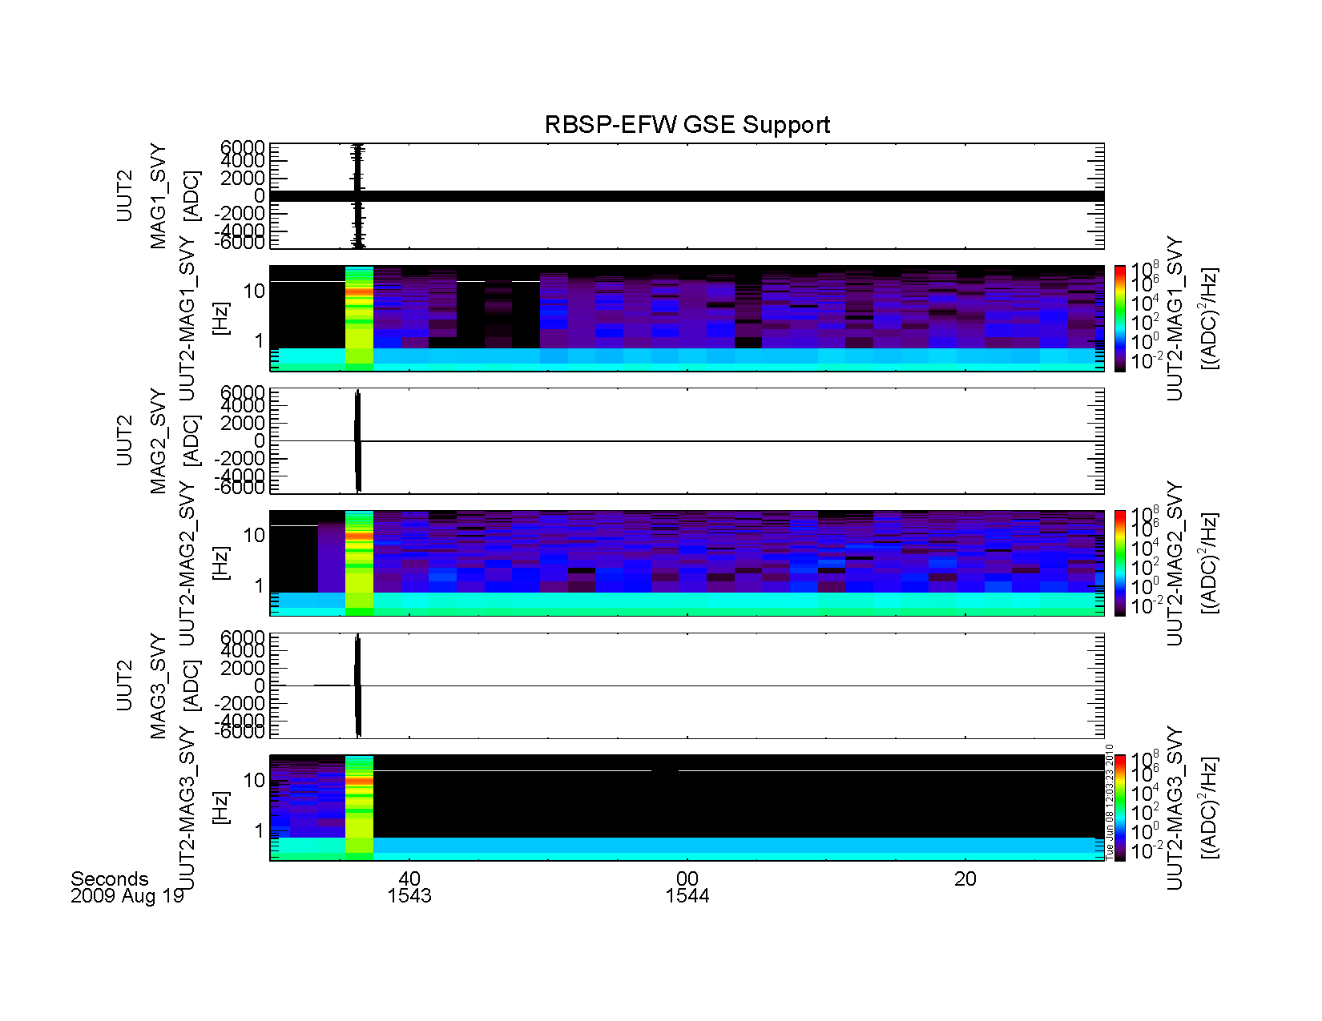

Figure 8: rb\_efw\_etu\_mag\_svy\_20090819\_194330\_001.png

This figure shows the response of the MAG to external exciation, along with the noise spectrum for an approximately 60-s period, 1543-1545 UT, 19 Aug 2009.

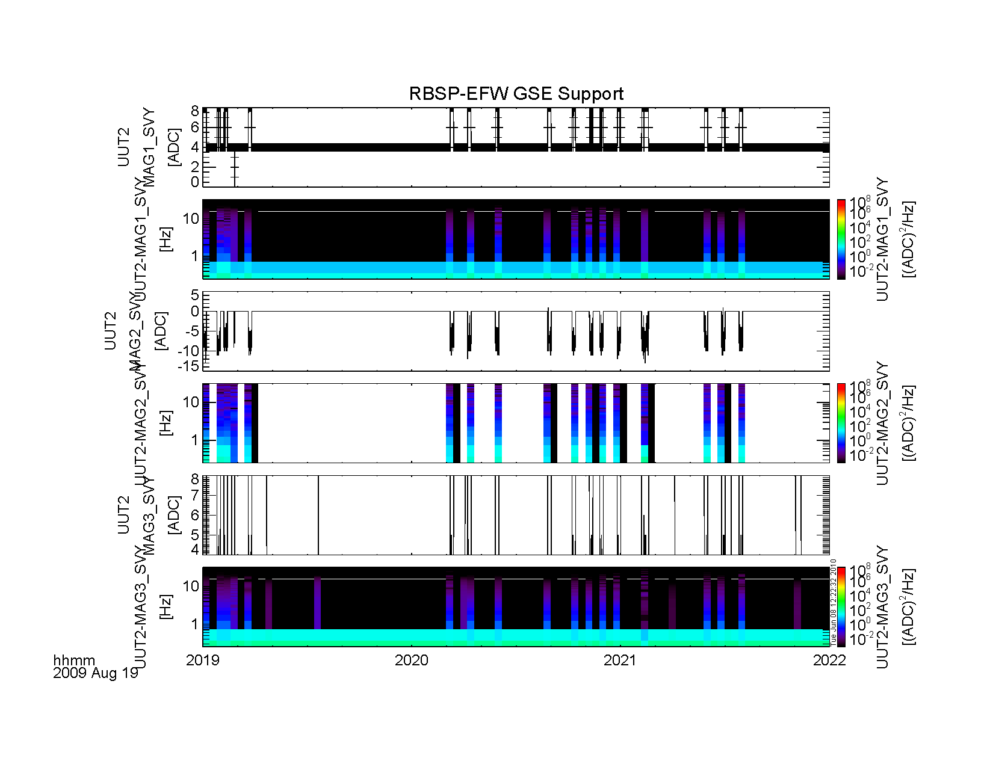

Figure 9: rb\_efw\_etu\_mag\_svy\_20090819\_201900\_001.png.

This figure shows the intermittent offsets and noise on the MAG channels that arise most probably from the DFB FPGA waveform processing bug described above. The fluctuations are still only a few ADC in peak-to-peak amplitude.

|  |  |  |
| --- | --- | --- |
| rb_efw_etu_mag1_svy_20090819_194330.png | rb_efw_etu_mag2_svy_20090819_194330.png | rb_efw_etu_mag3_svy_20090819_194330.png |
| **rb\_efw\_etu\_mag1\_svy\_20090819\_194330.png** | rb\_efw\_etu\_mag1\_svy\_20090819\_194330.png | **\_efw\_etu\_mag2\_svy\_20090819\_194330.png.** |

This figure shows time averaged line spectra taken from selected intervals in Figure 9. The spike in the lowest frequency bin is due to the DC offset level. The noise level similar between MAG1 and MAG2; the noise spectrum is much smaller on MAG3, due to a lack of fluctuations.

Even with the intermintent noise spikes due to the FPGA bug, the noise levels are in spec for all but the least-sensitive MAG range (+/- 65knT).

.

# 20 August 2009: blah-de-blah configuration.

## 30 April 2010: revised EFW FPGA w/out truncation noise error.

The following two figures show the MAG data with the FPGA truncation error corrected. The intermittent noise spikes are gone, leaving behind only the low-level (~0.5 ADC RMS) noise. This is well within the spec for all MAG range states. This indicates that there will be a good chance that the flight configuration MAG interface will meet requirements for noise floor.

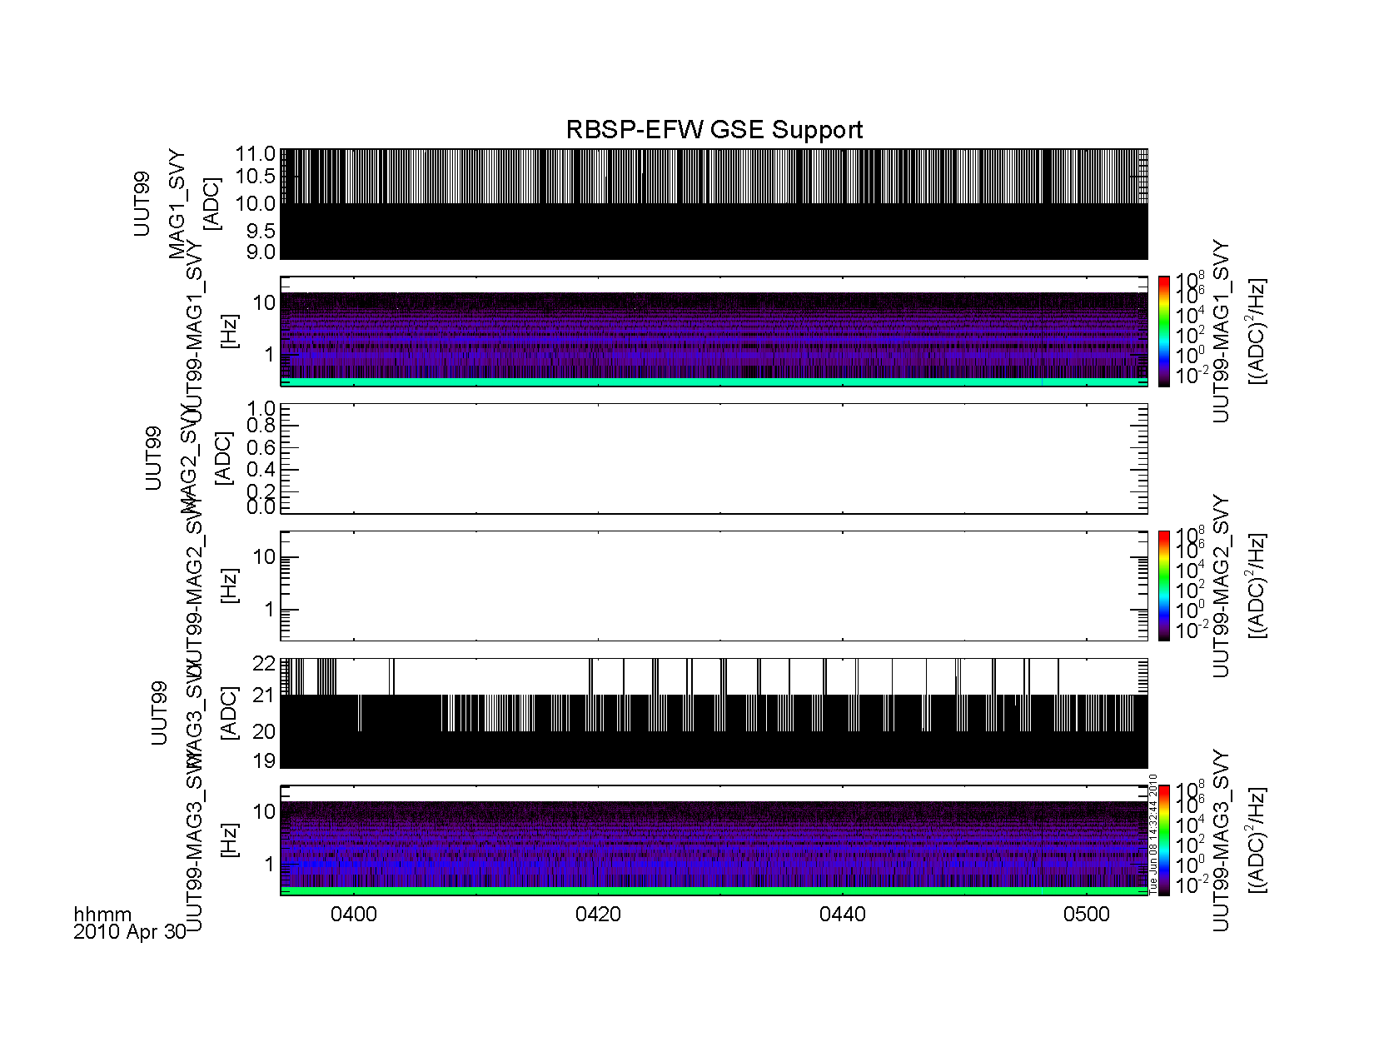

Figure 15: rb\_efw\_etu\_mag\_svy\_20100430\_0400\_0500\_001.png.

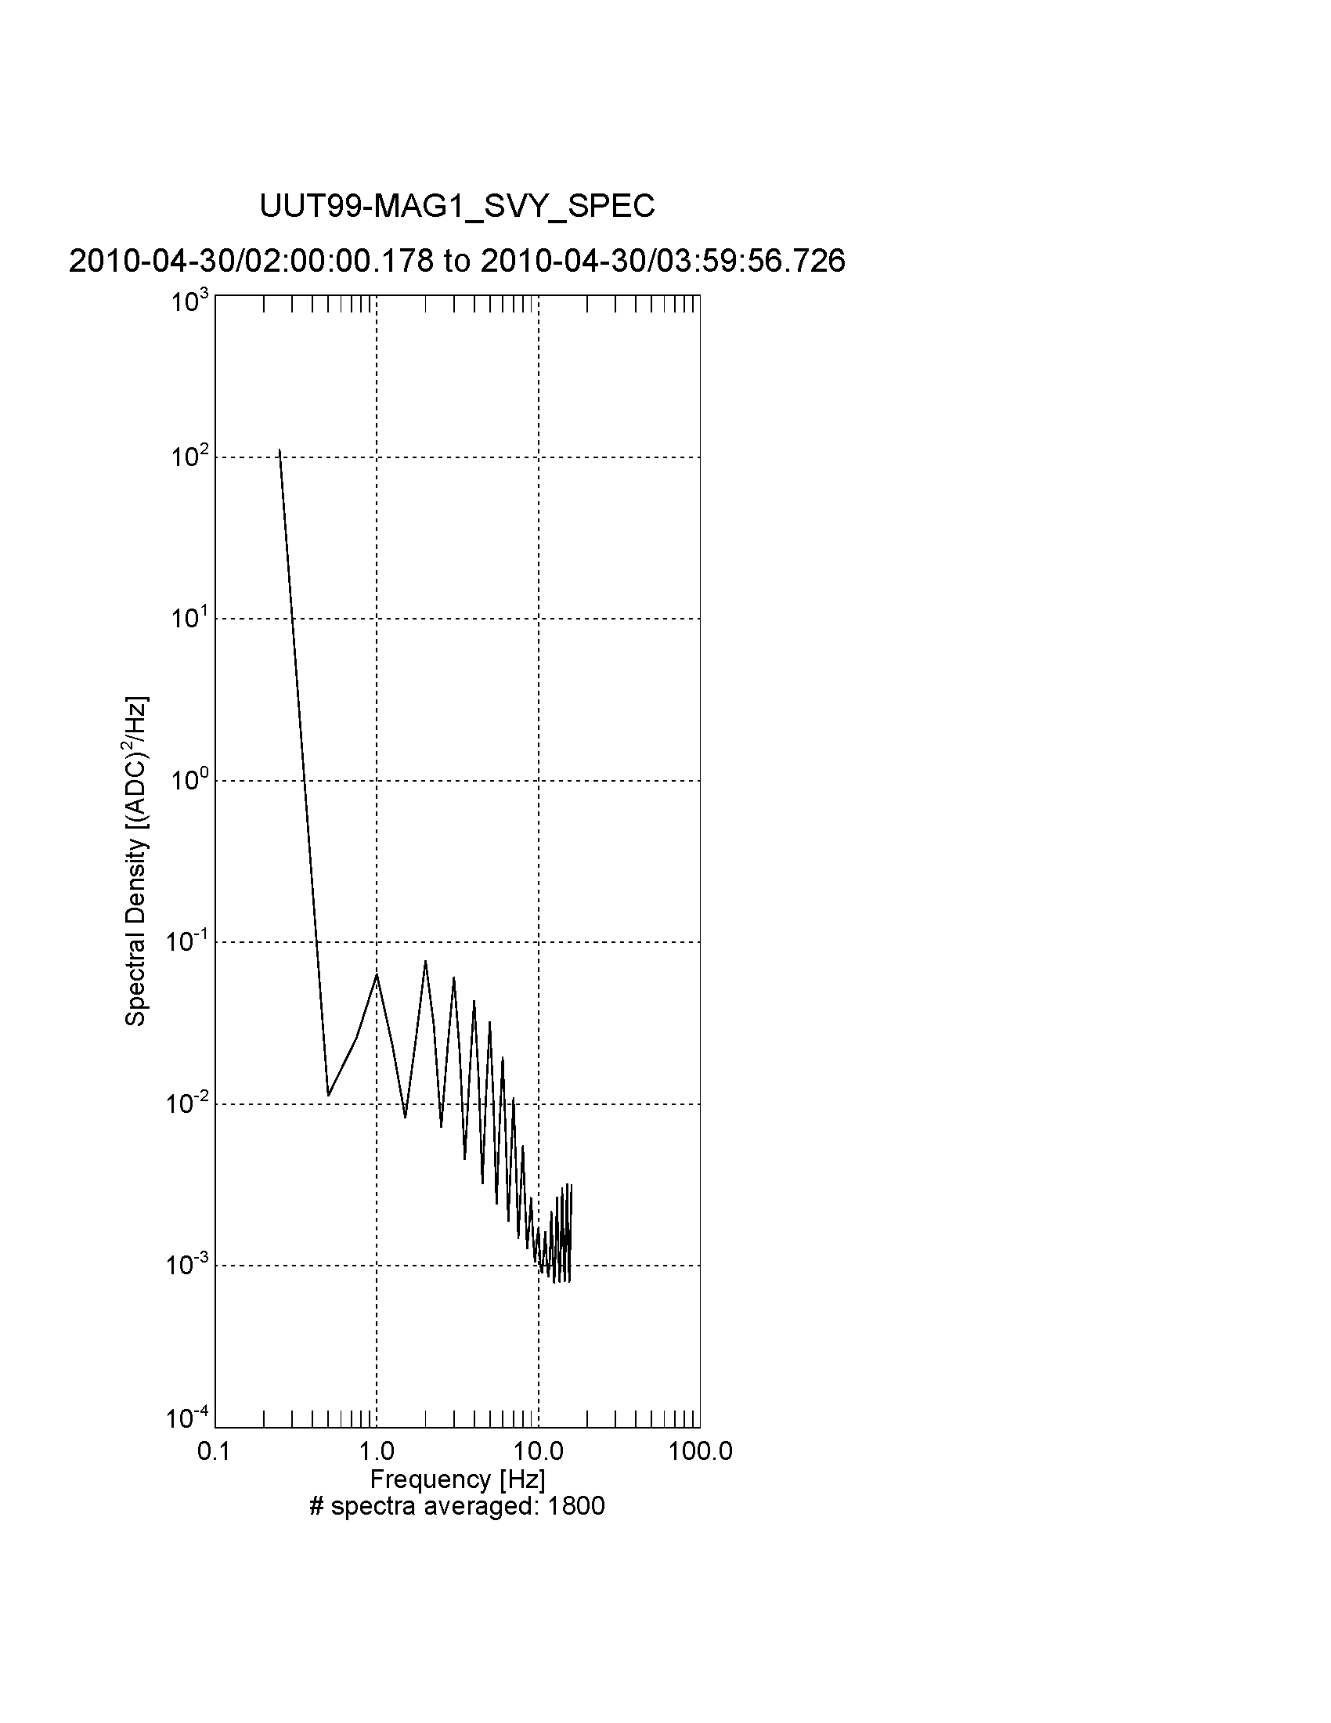

Figure 16: rb\_efw\_etu\_mag1\_svy\_line\_spec\_20100430\_0200\_001.png.

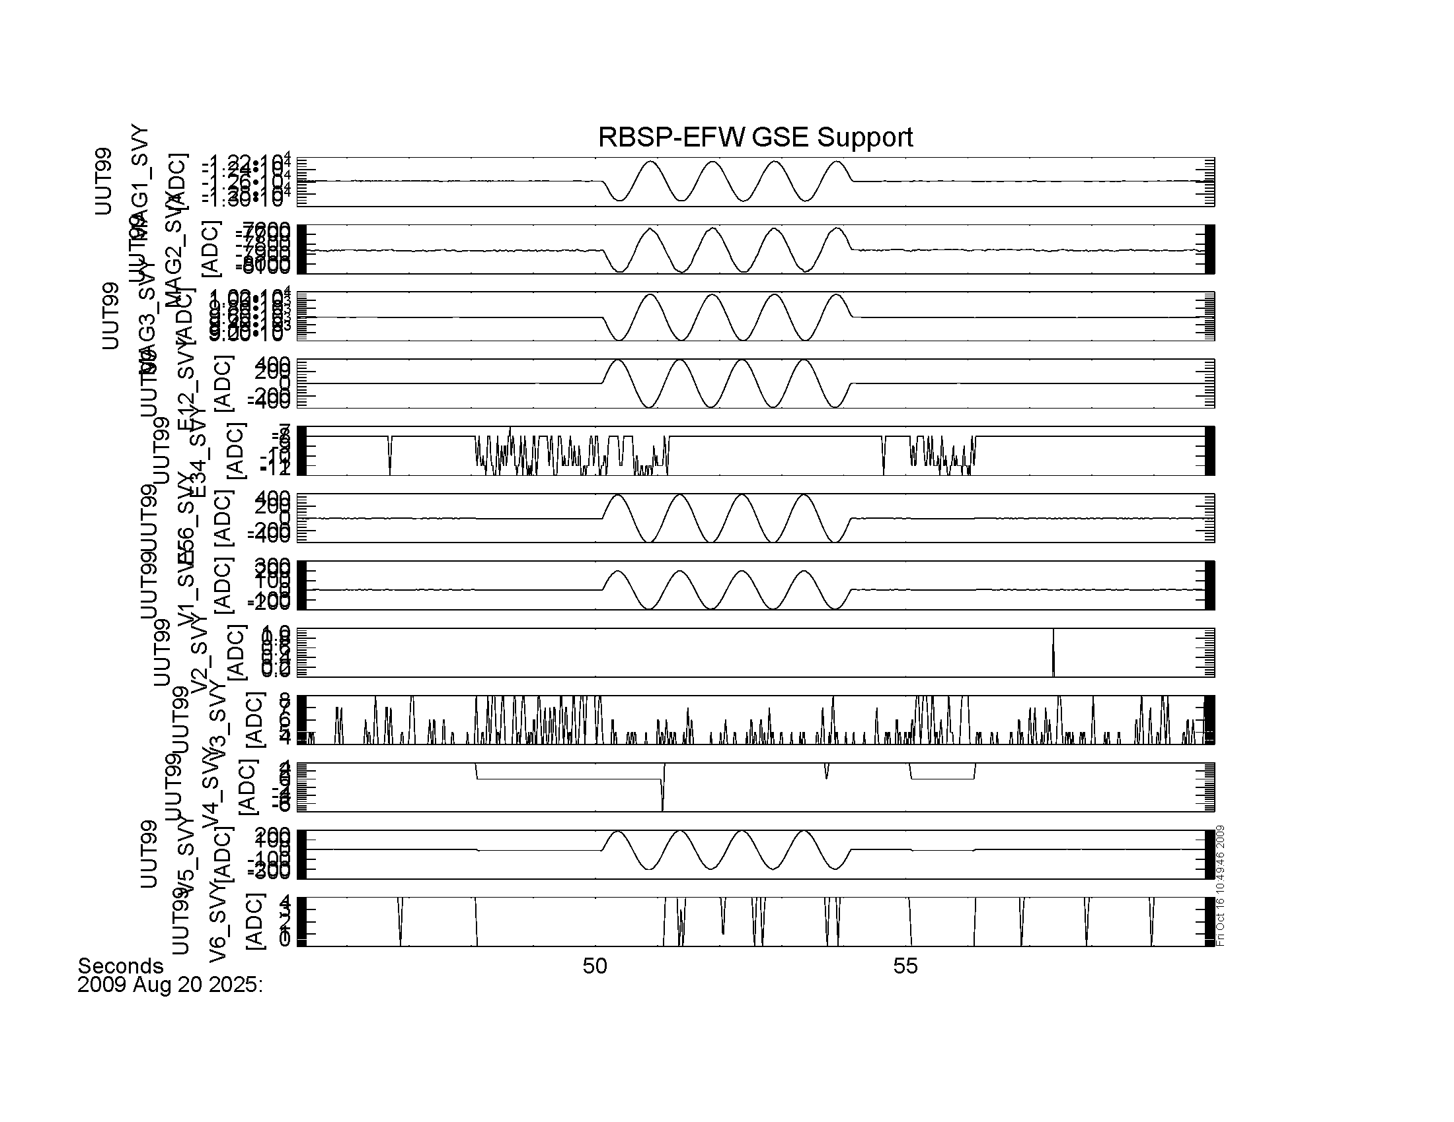

Figure 14: (rb\_etu\_efw\_emfisis\_20090820\_2025\_svy\_001.png).

This figure shows the response of the SVY channels to a full-up timing test excitation applied to the single-axis MSC/MAG coil apparatus, along with EFW analog inputs EF1 and EF 5 (V1 and V5). Top three panels are the MAG channels (APID 0x245); Next three panels are the E\_SVY channels (APID 0x243), followed by six panels of the single-ended VB-SVY data (APID 0x244).

More discussion of these data, along with the supporting B1 and B2 data later.

# End-To-END E-Field System Response

See ***RBSP-EFW-TN039A-Estimation of System Voltage Gain*** for estimate of system voltage gain versus frequency for the ETU system in the Playdate/I-CDR configuration, and motivations for changes to preamp and EMFISIS E-field interface buffers noted below.

# 24 May 2010 – End-to-End E-field System Response

Test Configuration:

* DCB ETU2 (8-FLASH)
* BEB ETU3 (revised EMF I/F, with change in BW and increased gain)
* LVPS ETU2
* PRE Flight-like ETU (Ce removed; 220-pF feedback capacitor; Rout 25-ohm)
* SPB ETU with flightlike cable, Partially-deployed in FBOX.

changes to Hardware from Analog I/F Playdate to May 2010 end-to-end response testing:

* BEB ETU2->ETU3:
  + EMF interface BW increased from XXX to YYY kHz.
  + Passband gain increased from 1.0 to 1.8 (TBR).
* PRE, ETU->Flight:
  + ESD bypass capacitor (Ce) removed.
  + 220-pF feedback capacitor added (see EFW-PFR-001 for discussion and details of rationale behind change).
  + Series output resistor (Ro) reduced in value from 100 ohm to 25 ohm.
* LVPS, ETU1 -> ETU2:
  + Layout changes.
  + Design Changes.
  + Noise Reduction.

Plot Descriptions:

covers 1 Hz to 100 kHz; second plot 10 kHz to 1 MHz. Magnitude of voltage gain is plotted versus frequency in each figure for several different input configurations and output signal points.

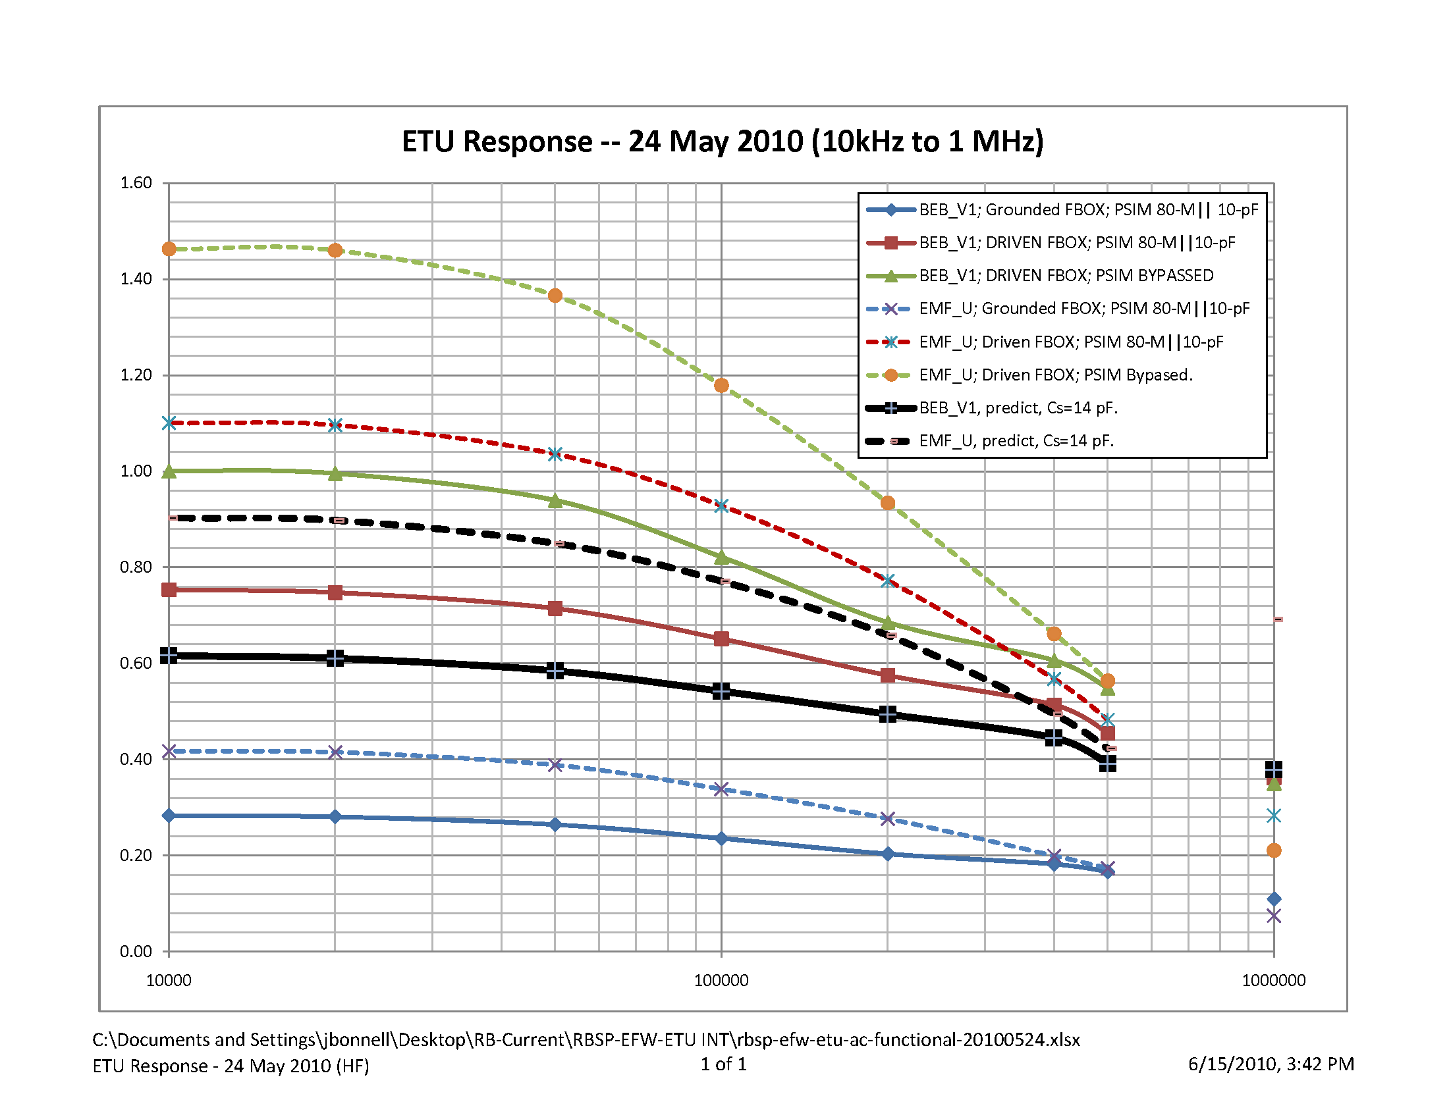Figure 17: Measured and Predicted SPB End-To-End Frequency Respose

Solid lines are the VSPHERE1 output on the BEB board relative to AGND (J709, SMA); dashed lines are the EMF U+ output on the BEB board (EFW-J703/EMFISIS-P503) relative to AGND.

Medium blue lines are in the FBOX GROUNDED configuration; red lines are in the FBOX DRIVEN configuration; medium green lines are in the P-SIM BYPASSED configuration; black lines are predicted gain curves using a sheath capacity of 14 pF (fully-deployed EFW-SPB Sensor).

Vin in each case is the Signal Generator output relative to AGND. Input was not 50-ohm terminated. Input signal amplitude was setup to be 1 Vpp, which for the high-impedance load the EFW preamp and FBOX represents, and the 50-ohm source impedance of the signal generator, lead to an input amplitude of ~2 Vpp.

Gain and phase shift estimated using native measurement capabilities of o-scope, and recorded manually in ***rbsp-efw-etu-ac-functional-20100524.xlsx.***

The magnitude of voltage gain is monotonically decreasing with frequency on all channels under all input configurations once one is above a few hundred Hz.

An important parameter for determining whether the EFW-EMFISIS E-field interface meets requirements is the voltage gain at 400 kHz, the nominal top of the EMFISIS HFR receiving band.

Table 2: Measured and Predicted Voltage Gain at 400-kHz for RBSP-EFW SPB Flight-like Hardware.

|  |  |  |
| --- | --- | --- |
| **Voltage Gain and Equivalent Attenuation (dB) at 400 kHz** | | |
| **Input Configuration** | **BEB V1 Output** | **BEB EMF U+ Output** |
| 80-Mohm || 10-pF P-SIM; FBOX Grounded | 0.18/-15 dB | 0.20/-14 dB |
| 80-Mohm || 10-pF P-SIM; FBOX Driven | 0.51/-6 dB | 0.57/-5 dB |
| P-SIM Bypassed. | 0.61/-4 dB | 0.66/-4 dB |
| Predict for Flight SPB, Cs=14 pF | 0.45/-7 dB | 0.50/-6 dB |
| Original Predict (14 Dec 2009), Cs=14 pF | Not computed. | 0.19/-14 dB |

As discussed in ***RBSP-EFW-TN039A-Estimation of System Voltage Gain***, the stray capacitance between the EFW sensor and the body of the Faraday Box (FBOX) used to shield the sensor from external fields produces an unavoidable impact on the measured frequency response of the sensor. By estimating the voltage gain in various input configurations, and applying a model for the voltage division occuring at the input of the EFW sensor-preamp combination, the magnitude of the stray capacitance along with the effective input capacitance of the preamplifier can be estimated, and the expected voltage gain for various on-orbit conditions estimated.

The test configurations were as follows: (a) the FBOX is connected directly to AGND (GROUNDED configuration) and the signal generator is connected to a plasma simulator (P-SIM) in series with the EFW sensor input; (b) the FBOX is connected directly to the signal being used to drive the plasma simulator (P-SIM) circuit in series with the EFW sensor (DRIVEN configuration); and (c) FBOX in either configuration, with the P-SIM bypassed and the Sensor directly driven by the signal generator (BYPASSED configuration).

Based on these measurements and predictions, the voltage gain at 400 kHz on the EMFISIS Eu interface has increased by a factor of ~2.5, which improves the signal-to-noise relative to the floor measured at the I/F Playdate from approx. 1 to 6.

In addition, measurements of the noise floor of the EMF E-field interface using the LVPS ETU2, rather than the ETU1 which was used in the Analog I/F test demonstrate an even greater increase in the signal-to-noise ratio due to a significant decrese in the continuum background and line emissions in the system.

This is shown in Figure XXX, which plots the spectrum analyser output from 0 to 500 kHz (50 kHz/div) as measured on the EMF E-field interface in Dec 2009 (***EMFISIS Noise.xls***). for reference, the two obvious spikes in the measured spectrum are at 200 and 400 kHz. The spectrum was measured through the EMFISIS WAVES Receiver simulator box , running on a separate bench supply than the EFW ETU. The BEB used in this case was BEB ETU2, which does not implement the gain and BW enhancements found in the BEB ETU3 EMF interface.

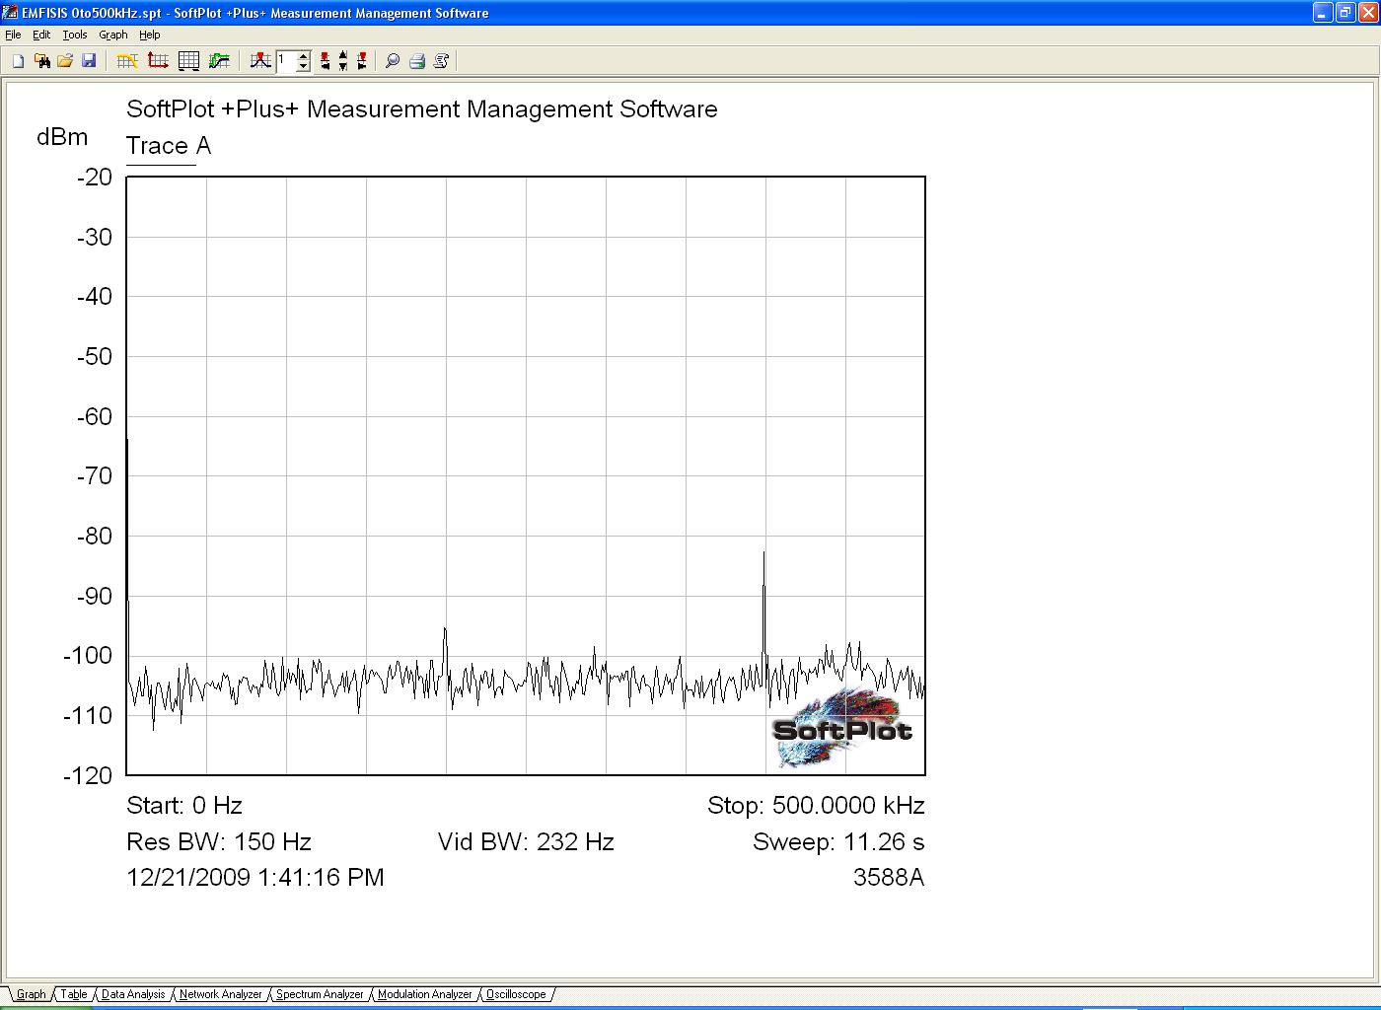

Figure YYY below shows the noise spectrum converted from dBm to dB uV, along with the noise floor specification from the EFW-EMFISIS ICD. Given that this measurement showed about 10dB of margin between the peaks of the continuum noise floor and the noise floor spec, and that the frequency response of the system at 400 kHz has been improved by a factor of 2.5 in voltage gain (8 dB), relative to these measurements, it is expected that the the Flight E-field interface should have around 18 dB of S/N margin in the hundreds of kHz band. This is a significant increase in the margin for this channel above the noise floor, and indicates that the Flight interface has a very good chance of meeting measurement requirements.

