RBSP EFW Preamp Testing Results

Version -: Initial release.
Rachel Hochman, UC Berkeley Space Sciences Lab

20 October 2008-
PWB Serial #: RBSP SPBETU #1
According to the electrical test procedure (Document: THM_EFI_PWB_TEST_PROCEDURE_REVB4) we verified the PWB part load and electrical circuit (i.e. pin continuity and isolation). We then proceeded to verify the board electrical operation, measuring gain and phase vs. frequency. For comparison we performed the same tests on one of the THEMIS Flight Spare boards, “EFI_PREAMP REV4”.
We plugged the PWB into a breakout board and powered the board with +15V and -15V. We then used a signal generator to pass a signal through a plasma simulator and onto the sensor input coil. Using an oscilloscope, we measured V_{in} at the front end of the plasma simulator and V_{out} on the V_{out} pin of the board.
The bias pin was left open and Usher, Guard, and Shield were attached to ground.

On our first run through we noticed a lot of noise on the 60 Hz frequency and decided we needed to shield the test setup. After trying a number of different things we decided on a large sheet of aluminum under the setup and we duplicated the tests both with the aluminum sheet grounded and with it driven by the signal generator. We then took our measurements with a V_{in} of around 2 V and swept the frequency from .1 Hz to 2MHz. On the next two pages are the results from the THEMIS and RBSP preamp boards with both driven and grounded foil beneath the setup. The different boards behaved identically in each setup.

One strange occurrence is the appearance of an oscillation on the downslope of the voltage sine wave at the higher frequencies (from 200kHz to 2MHz, mostly starting at 500kHz). This can be seen in the attached screen shots.

Screen Shot Keyg:

Shot Board Foil Frequency
TEK00000.pcx RBSP grounded 2MHz
TEK00001.pcx RBSP driven 500kHz
TEK00002.pcx RBSP driven 1MHz
TEK00003.pcx RBSP driven 2MHz
TEK00004.pcx THEMIS driven 200kHz
TEK00005.pcx THEMIS driven 300kHz
TEK00006.pcx THEMIS driven 500kHz
TEK00007.pcx THEMIS driven 1MHz
TEK00008.pcx THEMIS driven 2MHz
TEK00009.pcx THEMIS grounded 500kHz
TEK00010.pcx THEMIS grounded 1MHz
TEK00011.pcx THEMIS grounded 2MHz

Results

24 October 2008-
Large Amplitude Testing

We kept the same setup for this test, but input a signal with a much larger peak to peak voltage- in the range of 30-90 V. We again measured the V_{in}, V_{out}, and phase difference. Additionally, we measured the fast Fourier transform (fft) at 2f_{o} and 3f_{o} for both the input and the output. The results for the RBSP SPBETU #1 can be found in the charts below. The screenshots include V_{in}, V_{out}, and the fft for the output.

Driven Foil

f (Hz) | Vin (pp) | Vout (pp) | Phase (deg) | dB at output 2fo | dB at output 3fo | dB at input 2fo | dB at intput 3fo | i+ (mA) | i- (mA) | screen shot
100 | 31.2 | 25.2 | -6 | 38 | 61 | 49.2 | 49.2 | 4 | 3 | TEK00012.pcx
200 | 31.2 | 24.6 | -4 | 38 | 57 | 50.4 | 51.6 | 4 | 3 | TEK00013.pcx
300 | 31.2 | 24.4 | -3 | 37.6 | 54.8 | 47.6 | 58.2 | 4 | 3 | TEK00014.pcx
500 | 31.2 | 24.4 | -1 | 40.8 | 58.8 | 65.2 (52 @ 888Hz) | 58.8 (52 @ 1.11kHz) | 4 | 3 | TEK00015.pcx
1000 | 31.2 | 24.6 | -2 | 37.6 | 59.6 | 48.8 | 50.8 | 4 | 3 | TEK00016.pcx
5000 | 31.2 | 24.6 | -1 | 40.8 | 50.8 | 68.4 (52 @ 9.811kHz) | 57.2 | 4 | 4 | TEK00018.pcx
10000 | 31.2 | 24.3 | -6 | 38.4 | 65.2 | 50.8 | 56.8 | 4 | 4 | TEK00017.pcx
12000 | 31.2 | 24.5 | -4 | 40.8 | 61.6 (37.5 @22.8kHz) | 55.6 | 58.8 | 5 | 4 | TEK00019.pcx

Grounded Foil
f (Hz) | Vin (pp) | Vout (pp) | Phase (deg) | dB at output 2fo | dB at output 3fo | dB at input 2fo | dB at intput 3fo | i+ (mA) | i- (mA) | screen shot
100 | 53.1 | 25.1 | -36 | 41.2 | 49.2 | 52.4 | 51.2 | 4 | 3 | TEK00021.pcx
200 | 75.2 | 25.2 | -26 | 39.6 | 50 | 50 | 50 | 4 | 3 | TEK00020.pcx
300 | 90.2 | 27.1 | -21 | 35.6 | 48.4 | 49.2 | 62.4 | 4 | 3 | TEK00022.pcx
500 | 89.8 | 25.6 | -11 | 40 | 51.6 | 68 (52@ 890Hz) | 62 (52 @ 1.1kHz) | 4 | 3 | TEK00023.pcx
1000 | 89.8 | 25.2 | -7 | 38 | 65.6 | 48.8 | 51.2 | 4 | 3 | TEK00024.pcx
5000 | 90 | 25.3 | -1 | 39.6 | 50.8 | 68 (47 @ 8.75kHz) | 59.2 (50 @ 11.3 kHz) | 4 | 4 | TEK00025.pcx
10000 | 88.4 | 25 | -5 | 37.2 | 59.6 | 50.8 | 58 | 4 | 4 | TEK00026.pcx
12000 | 87.8 | 24.7 | -2 | 40.4 | 61.6 (37.2 @ 22.5kHz) | 55.6 | 56.8 | 5 | 4 | TEK00027.pcx

6 November 2008-
We built a faraday box to shield the setup from outside noise.
Then we found the offset voltage and the input bias current for the preamp. Out test setup remained almost the same, but we removed the plasma simulator and tied the input to ground to measure V_{os}. To measure V_{I}, we attached the input to ground through a 100M resistor. We also removed the capacitor that connected the output to ground and connected only our meter to V_{out}.

To find I_{B}, we simply take (V_{I}-V_{os})/R.

The results are below. We did notice that the offset voltage is proportional to temperature. The offset voltage went up when heat was applied to the top of the preamp board and down when heat was applied to the bottom of the board. This was true for both the RBSP and THEMIS boards.

RBSP Preamp:

V_{os}: .277 mV
V_{I}: .787 mV
I_{B}: 5.1 pA

THEMIS Preamp:

V_{os}: -.309 mV
V_{I}: .118 mV
I_{B}: 4.27 pA

9 February 2009-
AC Gain Calc
Calculations in notes in red binder.
Effective Input Capacitance: 6.72 pF. This is in the expected range of 6-10 pF.
Effective Stray Capacitance: 17.76 pF.

TEK00000.pcx

TEK00001.pcx

TEK00002.pcx

TEK00003.pcx

TEK00004.pcx

TEK00005.pcx

TEK00006.pcx

TEK00007.pcx

TEK00008.pcx

TEK00009.pcx

TEK00010.pcx

TEK00011.pcx

TEK00012.pcx

TEK00013.pcx

TEK00014.pcx

TEK00015.pcx

TEK00016.pcx

TEK00017.pcx

TEK00018.pcx

TEK00019.pcx

TEK00020.pcx

TEK00021.pcx

TEK00022.pcx

TEK00023.pcx

TEK00024.pcx

TEK00025.pcx

TEK00026.pcx

TEK00027.pcx

Axial Boom Preamp Testing

7 January 2009
PWB Serial #: RBSP_EFW_PRE_002 Rev B #1
According to the electrical test procedure (Document: THM_EFI_PWB_TEST_PROCEDURE_REVB4) the PWB part load and electrical circuit (i.e. pin continuity and isolation) were verified. Verification of the board electrical operation, measuring gain and phase vs. frequency, was conducted in the same manner as with the SPB preamp.
The PWB was plugged into a breakout board and powered with +15V and -15V. A signal generator provided a signal to pass through a plasma simulator and onto the sensor input coil. Measuring V_{in} at the front end of the plasma simulator and V_{out} on the V_{out} pin of the board, as well as the phase difference, was done with an oscilloscope. The bias pin was left open and Shield was attached to ground. Unlike the SPB preamp, Guard and Usher are connected inside the whip for the AXB preamp. The schematic for the preamp is as follows:
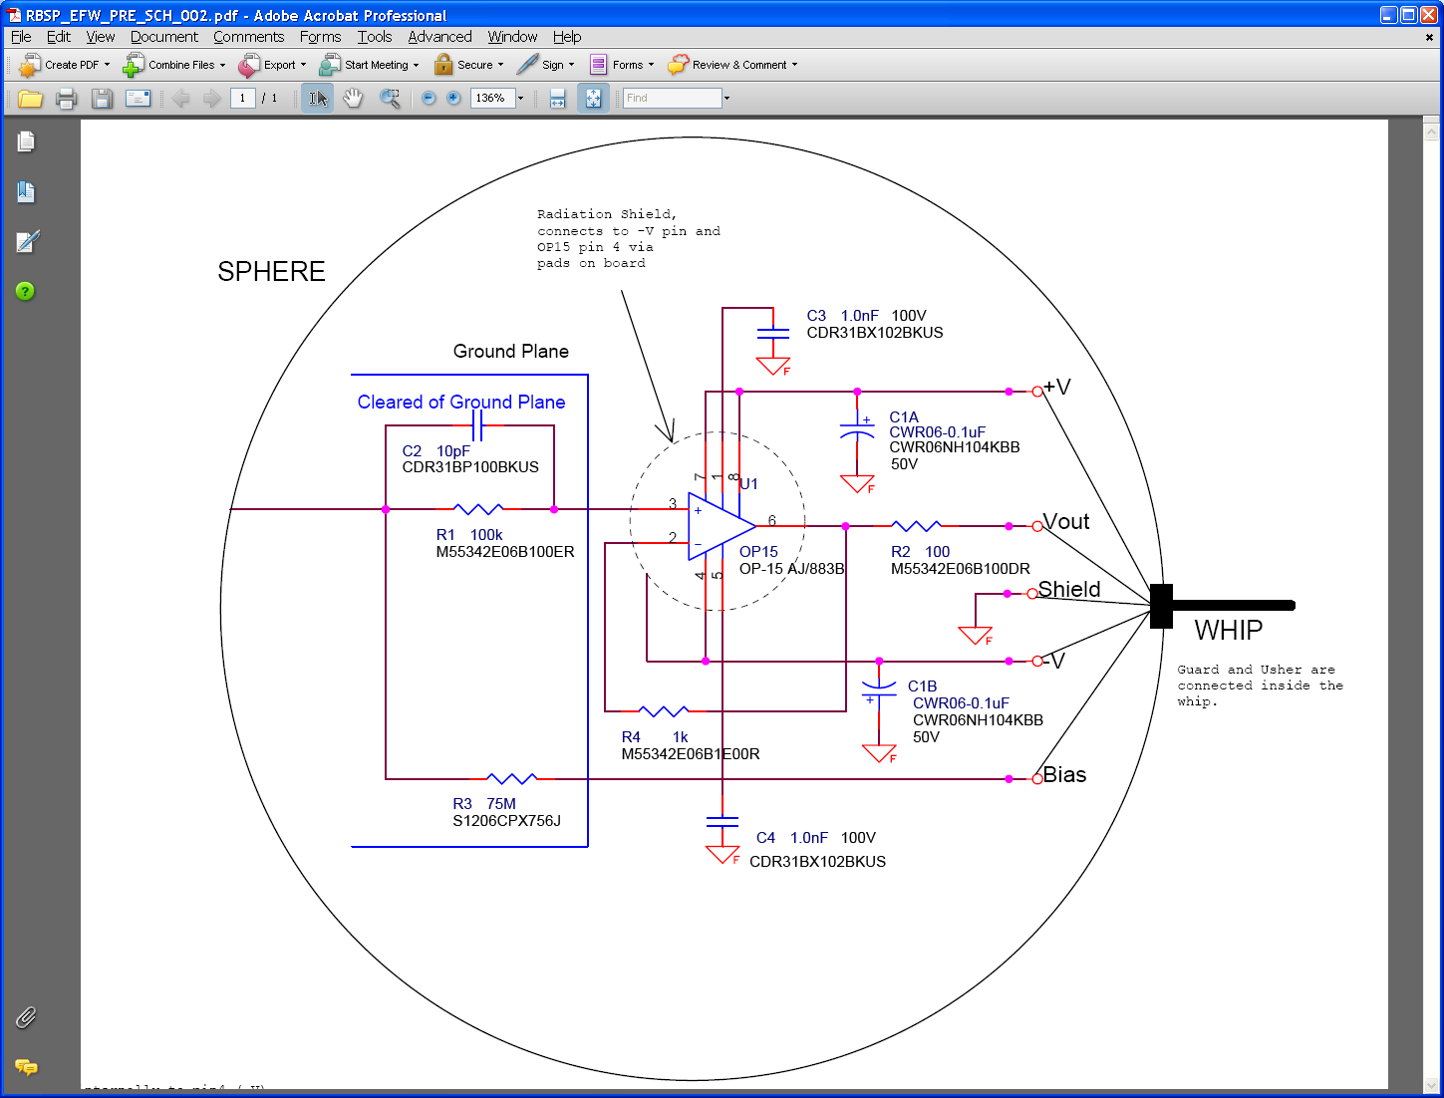

Measurements were made with a V_{in} of around 2 V with the frequency sweeping from .1 Hz to 2MHz. On the next two pages are the results with both a driven and a grounded faraday box around the setup. This board behaved much the same as the SPB preamp. The same strange ringing on the downslope of the voltage sine wave at the higher frequencies (from 200kHz to 2MHz, mostly starting at 500kHz) occurred for this board as well. This can be seen in the attached screen shots.

In addition to the 80M, 10pF plasma simulator, this test was run with a 5M, 22pF plasma simulator. The results are below:

15 January 2009-
Large Amplitude Testing

The same setup was used for this test, but the input signal was made sufficiently large so as to have the V out peak to peak be around 25 V. In addition to Vin, Vout and phase difference, the fast Fourier transform (fft) at 2f_{o} and 3f_{o} for both the input and the output were measured. These results are described in the charts below, and they greatly resemble the results of the SPB preamp.

Driven Box:
f (Hz) | Vin (pp) | Vout (pp) | Phase (deg) | dB at output 2fo | dB at output 3fo | dB at input 2fo | dB at intput 3fo | i+ (mA) | i- (mA)
100 | 25 | 25 | -2 | 44.4 | 55.6 | 42 | 52.8 | 3 | 3
200 | 25.6 | 25 | -4 | 59.6 | 52.6 | 44.8 | 55.6 | 3 | 3
300 | 26 | 25 | -5 | 44.4 | 50.8 | 50.4 | 63.2 | 3 | 3
500 | 26 | 24.4 | -6 | 50.4 | 55.2 | 48.8 | 45.6 | 3 | 3
1000 | 28.6 | 25 | -6 | 55.6 | 47.2 | 41.2 | 56.8 | 3 | 3
5000 | 30.8 | 25 | -2 | 44.8 | 55.2 | 45.6 | 53.2 | 3 | 3
10000 | 31.2 | 24.8 | -3 | 52.8 | 48 | 40.4 | 53.2 | 4 | 4
12000 | 30.8 | 24.8 | -4 | 43.6 | 48 | 47.2 | 54.4 | 4 | 4

Grounded Box:

f (Hz) | Vin (pp) | Vout (pp) | Phase (deg) | dB at output 2fo | dB at output 3fo | dB at input 2fo | dB at intput 3fo | i+ (mA) | i- (mA)
100 | 25.4 | 25.2 | -2 | 44.4 | 55.6 | 42 | 53 | 3 | 3
200 | 25.6 | 25 | -3 | 59.6 | 52.8 | 45.6 | 56.4 | 3 | 3
300 | 25.8 | 25 | -4 | 44.8 | 50.4 | 48.8 | 63.2 | 3 | 3
500 | 26.8 | 25 | -5 | 51.6 | 52.8 | 47.6 | 46 | 3 | 3
1000 | 28.6 | 25 | -5 | 53.6 | 47.2 | 41.2 | 58 | 3 | 3
5000 | 30.8 | 24.8 | -2 | 58.8 | 47.2 | 40 | 53.2 | 3 | 3
10000 | 31.8 | 25 | -5 | 48.4 | 52.4 | 42.4 | 53.2 | 4 | 4
12000 | 31.8 | 25 | -2 | 40.8 | 50.4 | 46.4 | 55.6 | 4 | 4

6 February 2009
Offset Voltage and Input bias Current
To find the offset voltage and the input bias current for the preamp, the plasma simulator was removed and the input was tied to ground. V_{os} was found by measuring Vout in this configuration . To measure V_{I}, the input was attached to ground through a 100M resistor and Vout was again measured. Vout was also read directly from the Vout pin, rather than through a capacitor to ground.

I_{B} is found by calculating (V_{I}-V_{os})/R.

The results are below. (We did notice that the offset voltage is proportional to temperature. The offset voltage went up when heat was applied to the top of the preamp board and down when heat was applied to the bottom of the board. This was true for both the RBSP and THEMIS boards.)

Vos=-.244 mV
Vi=.267 mV

Ib= 5.11pA

9 February 2009-
AC Gain Calc.

Effective Input Capacitance: 5.249 pF. This is slightly out of the expected range of 6-10 pF.
Effective Stray Capacitance: .099 pF.

Tested with 22 pF as Cs, but only in the driven formation. If stray capacitance was indeed .099pF, the effective input capacitance is 4.526 pF.

Reasons why the values for Ci would be so different?

