TN-015. Time
General. The RBSP spacecraft provides no clocks beyond the 1 pulse-per-second. In order to drive the sampling, EFW IDPU must provide its own clock and determine how that clock relates to the spacecraft 1PPS (+/-30 microsecs 3 sigma) in software and/or hardware.

Requirements. The RBSP requirement for EFW timing accuracy is 1 msec 3 sigma (MRD/ELE 212). The chosen standard packet time is 4 bytes of seconds and 2 bytes of sub-seconds. This provides precision to 16 microseconds. So, we need to be accurate to 10 bits of sub-seconds while we are providing 16.

Message Timing. The SC message coming to DCB can occur anytime in the second up to 50 msec from the SC 1PPS mark (see Figure 1). The time message indicates the MET at the next 1 second tick. It is required that the software keep track of the order of the message and the 1PPS tick, else be off by 1 second. Currently, it is thought that the FSW will use a SC-relative timer of 256 Hz that enables decoding the MET prior to the SC 1PPS mark, or FSW could decode the MET when the SC 1PPS is detected.

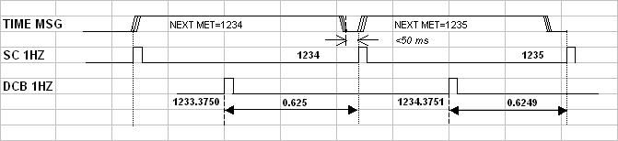
SC .v. DCB 1Hz Pulses. Since the SC and DCB have different clocks, the 1 PPS pulses can occur in any phase relationship. It is even possible that two SC 1PPS pulses will occur within one DCB second, or even that no SC 1PPS pulses occur within one DCB second.

Figure 1. Message Timing and Clocks

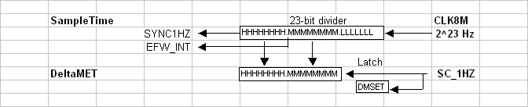
SampleClock. As shown in Figure 2, the DCB timing circuitry uses a 23-bit register to count the 8MHz (CLK8M), providing both a 1 Hz (SYNC1HZ) signal, and a 256 Hz (EFWINT) used to drive the computer interrupt timing. Thus, the computer software intrinsically is in sync with the 1Hz ticks.

Figure 2. Timing Circuitry in the DCB

DeltaMET. This 16-bit register is jammed with SampleTime when the spacecraft 1 Hz tick (SC_1Hz) occurs. At the same time, a status bit (DMSET) is set to 1, so that FSW knows to read the value of DeltaMET, and that the pulse has occurred. DeltaMET is not guaranteed to change when there is a new second. Since a rising signal on DMSET flags a new second, software is basically guaranteed that DeltaMET will be stable for almost another second.

DFB Timing. The Digital Fields Board (DFB) runs it’s A/D and FPGA using the EFW clock (2²³ Hz) and DCB 1PPS for synchronization. The DCB collects samples in sync with the DCB 1PPS. DMA channels “swap” to end packets on the second or binary sub-second (e.g. 1/64 second). Based upon this synchronous design, the packet times are known relative to the DCB in a very regular way. If there are 4 packets per second, then the “packet-offset” time simply advances by 0.250 second each time.

Packet Time. FSW is tasked with generating the packet time in terms of the SC MET, to a precision and accuracy described above.
The following examples show the EFW method for determining packet start times in Spacecraft Mission Elapsed Time (MET).

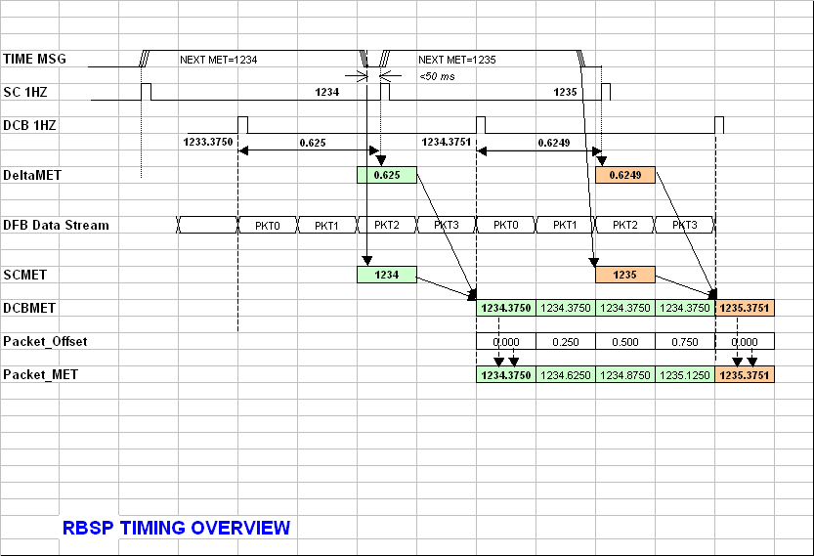
Example 1. Packet Time Calculation
(Source: RBSP_EFW_FSW_004_Analyses.xls)
Example1 shows the basic timing and phasing of the information using a 4Hz packet rate. In this example, the Spacecraft 1PPS is behind the EFW 1PPS by 0.625 seconds in the first second, and then behind by .0615 seconds in the next second.

Starting at the top of the figure, these are the salient notes:
[1] SC messages bring in NEXT_MET values of 1234 and 1235, respectively;
[2] The IDPU FSW receives the packets, decodes the time block and stores the 4-byte METs in local RAM;
[3] At SC_1Hz ticks, the DeltaMET register is latched in hardware (0.625 and 0.6249, respectively), and FSW records the SCMET as 1234;
[4] At EFW_1Hz, FSW reads DeltaMET and calculates the next DCBMET as follows:
DCBMET = SCMET-Delta_MET+1;
[5] The DFB generates packets (in this case at 4 Hz) and the DCB DMAs swap every 250 msec relative to EFW_1Hz.
[6] For each packet, FSW computes the Packet_Offset for each packet (.00,.25,.50,.75 relative to DCB 1PPS). FSW uses the upper bits of the synchronous interrupt clock to do this;
[7] The FSW calculates the Packet_MET using the formula
Packet_MET = DCBMET+Packet_OFFSET;
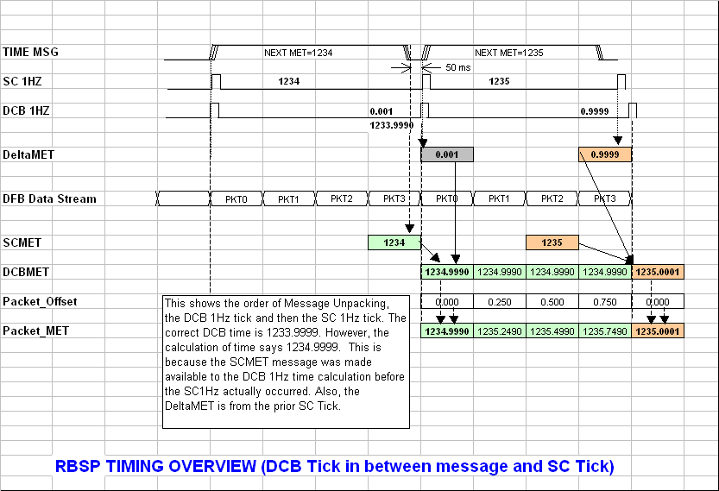
Example 2. Order Preservation
(Source: RBSP_EFW_FSW_004_Analyses.xls)

In the above example, the importance of preserving the proper order in time-tagging is illustrated. As shown, the DCB 1Hz tick occurs between the TIME Message and the S/C 1Hz. If FSW unpacks the SCMET in preparation for the SC 1Hz tick, and then the DCB 1 Hz occurs, the DeltaMET is incorrect, and the calculation of DCBMET is forward by one second.

It is recommended that the FSW either [1] unpacks the time message to a temporary register to be latched at the recognition of SC 1Hz; or [2] the recognition of SC 1Hz initiates the unpacking of the TIME MSG.
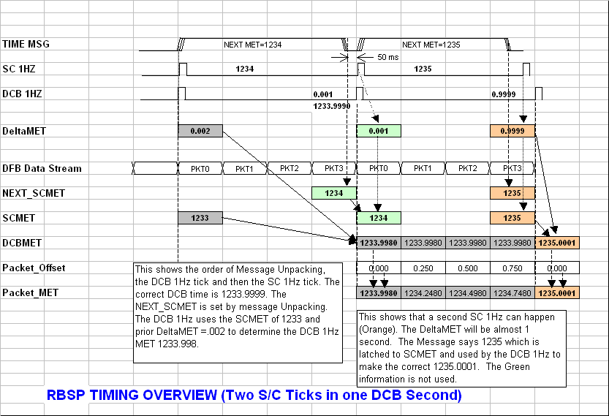
Example 3. Two Ticks in One
(Source: RBSP_EFW_FSW_004_Analyses.xls)

Example three shows the case in which the S/C clock is going faster than the DCB clock. For illustration, there are three ticks shown, colored grey, green and orange. The green and orange ticks occur within the same “DCB second”.

In this diagram, the middle DCB1Hz occurs just prior to the SC 1Hz, thus the DCB 1Hz logic does not know how long to wait for the SC 1Hz. Thus, the middle DCB 1Hz calculates its time using the only known information at that time, namely the grey-colored DeltaMET and the SCMET of .002 and 1233, respectively. The DCB MET is thus 1233.998, using the formula DCBMET=SCMET-DeltaMET+1.

On the third tick, the SC 1Hz occurs before the DCB 1Hz. The DeltaMET is nearly 1 second, and the SCMET is set to the NEXT_MET of 1235 already. The DCBMET is calculated based upon the orange data, skipping the green information.
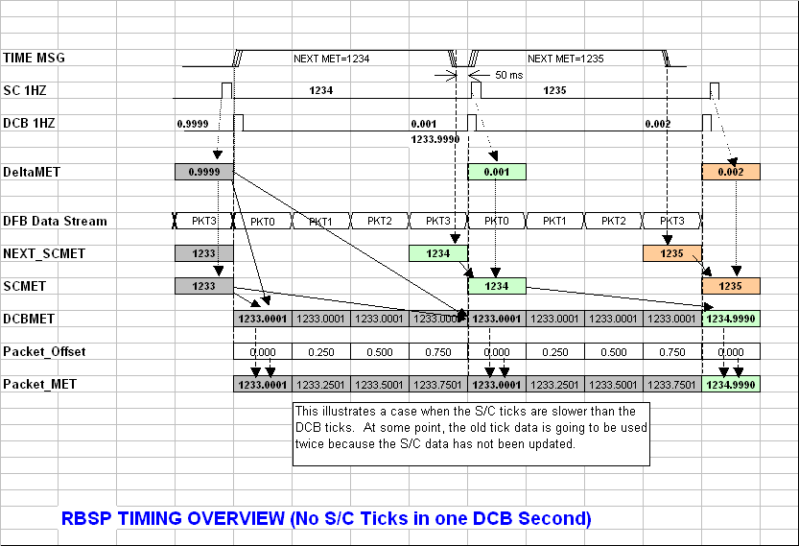
Example 4. S/C Clock is Slow
(Source: RBSP_EFW_FSW_004_Analyses.xls)

Example four shows the case in which the S/C clock is going slower than the DCB clock. For illustration, there are three ticks shown, colored grey, green and orange. The grey and green ticks span more than one “DCB second”.

In this diagram, the left DCB1Hz occurs just after the SC 1Hz and correctly determines its MET as 1233.0001, using the formula DCBMET=SCMET-DeltaMET+1.

On the second tick, the DCB 1Hz occurs just before the SC 1Hz. The DeltaMET is no longer valid, still showing the value from the prior second, and the SCMET is still the prior value. Thus, the DCBMET is unchanged from the prior second.

As a practical matter, it is likely that the GSE will need to be stopped and started periodically, and it would be good to have the instrument time keeping proceed without the GSE to provide Messages and Ticks. So, it would be nice to extrapolate the FSW actions for example 4 to solve the case in which no time messages come in (FSW keeps time using the DCB time).

