TN-009. Boom Alignment
Below are graphical analyses for the SPB and AXB mounting errors. I’ve taken John Wygant’s desire to keep the SPB wire alignment error to 0.1 deg or less and distributed the resulting tolerances in a way that seems comfortable. I’ve put a true position tolerance of .080” on the SC SPB bolt hole locations, and no alignment of the units (beyond bolt fits) will be required. Likewise, a max .005” clearance between the AXB flange locating bosses and the deck inserts is plenty tight and will require no alignment. – Paul Turin

For your Pointing Budget Trees:

SPB:

Boom Mounting Alignment Tolerance:
.080” TP bolt hole pattern location with respect to the SC coordinates, .010” within the pattern

Boom Thermal Distortion (mounting alignment):
Negligible

Boom Thermal Distortion (deployed):
Wire CTE = 14ppm/C

SPB Sensor Alignment to Boom:
Since the wire is floppy and so will sit on a radial line form the boom hinge point, I think this is automatically perfect.

SPB Thermal Distortion (Pre-Amp CTE):
I don’t think this makes sense for a short (<1”) coaxial axisymmetric body – maybe replace with the Fine Wire (between preamp and sphere) CTE = 17.2PPM/C?

AXB:

Boom Mounting Alignment Tolerance:
Max .005” clearance between boom flanges and deck inserts = .054” radial offset at boom tip. There is the additional factor of the insert locations with respect to the spacecraft Z axis. On Themis we defined the AXB tube as the Z axis for the purposes of alignments and spin balance. For RBSP, it would make sense (in my EFW-centric world) to use the AXB deck inserts for this purpose, as they are easy to pick up, and this would avoid introducing another error in the boom position. If you don’t want to do this, then you need to add your positional tolerance of the inserts with respect to whatever is your reference.

Boom 1G release:
Don’t think this is a factor for the stowed unit (no alignments done in this state). For the deployed unit, this is accounted for in the boom deployment error

Boom Deployment Error:
3” radially max

Boom “Wobble” Error:
I take this to mean deflection due to radial acceleration acting on the static Boom deployment error on a spinning spacecraft = .94”

Boom Thermal Distortion:
.13” radially @5rpm. This is in the antisunward direction minus a phase angle and so is spinning in the spacecraft coordinate system.

AXB Sensor/Whip Mounting Alignment Tolerance:
.10” radially

AXB Sensor 1G Release
Same comment as for AXB boom
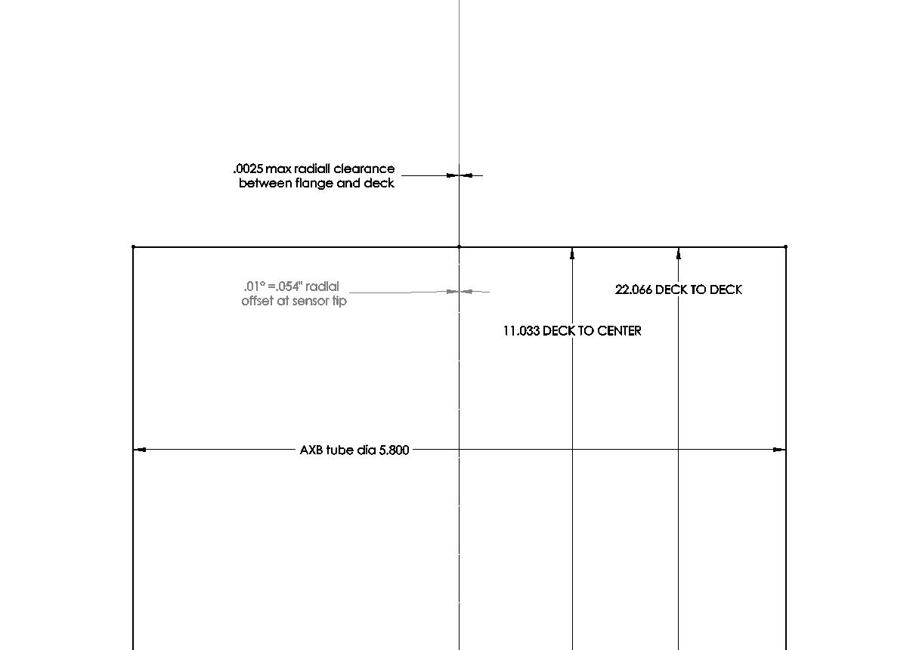
AXB Worst Case Rotation

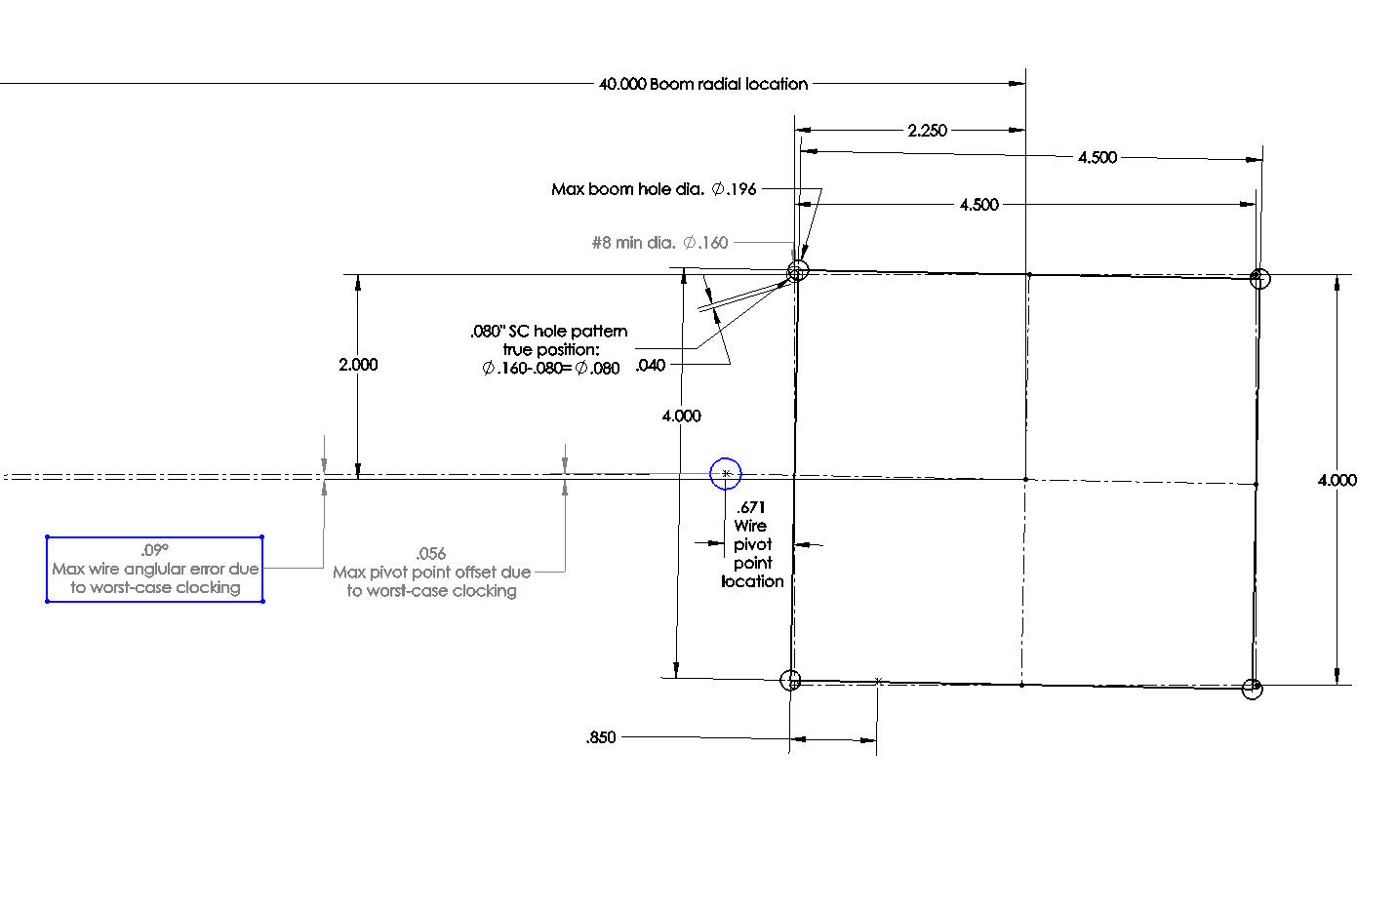
SPB Worst Case Rotation
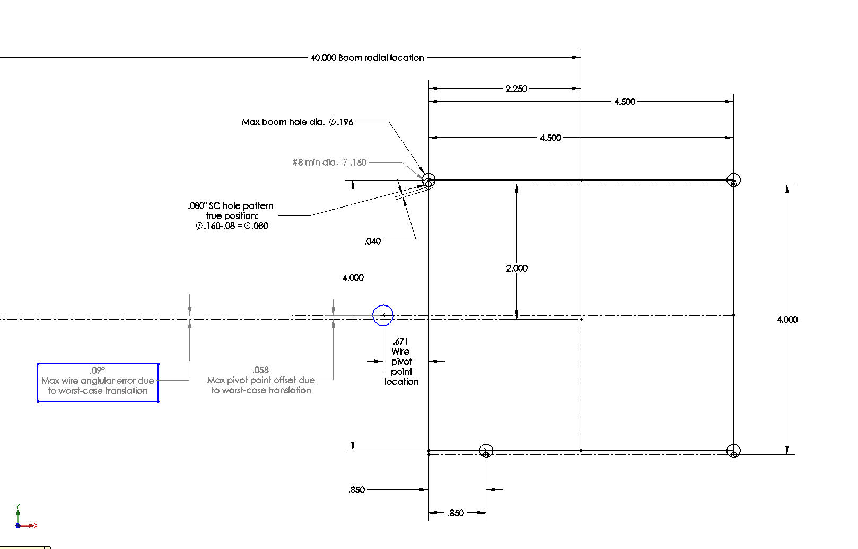
SPB Worst Case Translation

