TN-002. SPB Motor Current Measurements
General. The RBSP EFW Spin Plane Boom motor start up curve is the peak power for the SPB motors. In past projects, the surge current to the motors have concerned power designers who would like to limit the supply to something sensible while providing as much initial start up current as possible. Limiting a motor in its start up can cause a stall condition which can damage the motor.

System considerations such as harnessing lengths, connectors, control FET conductance and temperature are not always controllable. It is difficult therefore to properly measure motor currents while in the system configuration. Thus, the effort to go directly to the motor itself.

Configuration. The battery simulator used a 2.5 A power supply with a 0.1F capacitor.
The voltage was set to 34V (Maximum bus Voltage). These were harnessed to a Breakout Box and directly to an SPB Simulator. The current probe was set to 500 mA and the oscilloscope set to 5mV/div, giving 250mA/division on the scope.

Procedure. The test consisted of a hard turn-on of the motor using no switches or other circuitry in the loop. This was to remove all sources of impedance and find the worst case. The following pages show these waveforms.

Results. The SPB inrush is surprisingly well behaved. There was no evidence of a large (>5A) spike upon turn on.

Figure 1. Motor Start at 34V
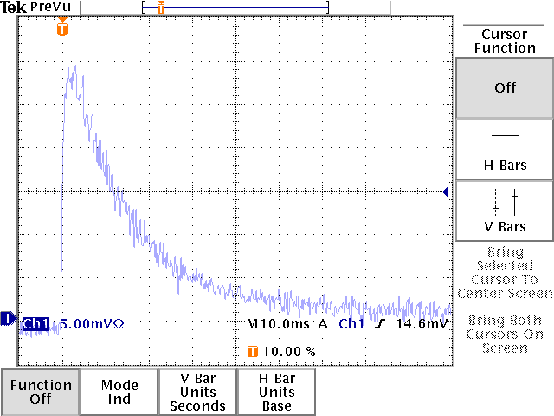

The above curve was taken with a SPB simulator SPB_SIM001, 34V input

Turn On. The peak current shown on the plot is 1.45 A. The motor achieves full speed in 60 msec. There appears to be no turn on spike in this time scale.

Nominal. The running current shown on the plot is approximately 0.1 A
.

Figure 2. Motor Start at 34V Expanded Time
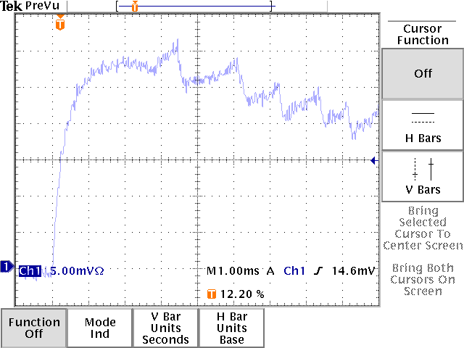

The above curve was taken with a SPB simulator SPB_SIM001, 34V input

Turn On. The peak current shown on the plot is 1.60 A (250mA/div). There is no apparent high current spike visible in the plot.

Figure 2. Motor Start at 22V Expanded Time
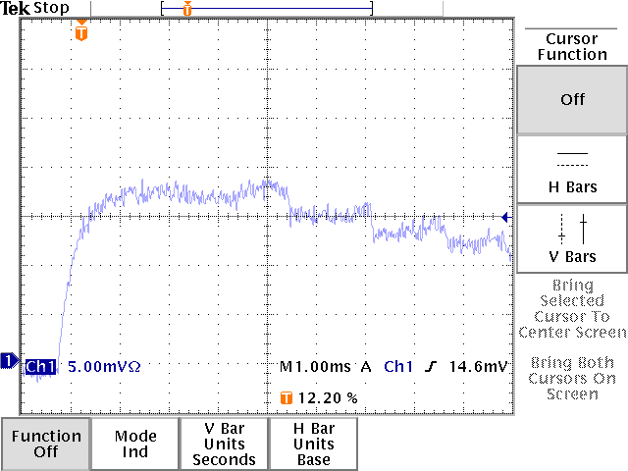

The above curve was taken with a SPB simulator SPB_SIM001, 22V input

Turn On. The peak current shown on the plot is 0.90 A (250mA/div). There is no apparent high current spike visible in the plot.

